

**Web Application Pen-Testing**

Year 2 (2025/26), Semester 3

**SCHOOL OF INFOCOMM TECHNOLOGY**

Diploma in Cybersecurity & Digital Forensics

**ASSIGNMENT**

Table of Contents

Executive Summary 3

Approach 3

Scope 3

Overview 4

Pentest Walkthrough 5

Reconnaissance 5

1. Nmap 5

2. Whatweb 5

3. Gobuster 7

4. Amass 7

Exploitation 9

1. Cross-Site Scripting (XSS) 9

2. Broken Access Control 16

3. SQL Injection 23

4. Path Traversal 29

5. Insecure Direct Object References (IDORs) 32

Appendix 39

1. Wafw00f 39

2. Zaproxy 39

3. Gobuster 40

4. XSS Payloads 43

5. Path Traversal 44

6. Amass subdomain scan 44

# Executive Summary

My team decided to perform pen-testing on WestJet’s website through their bug bounty program on Bugcrowd to find out any potential vulnerabilities or weaknesses on their website.

Our goals were to:

1. Assess the attack surface on [www.westjet.com](http://www.westjet.com) that could result in damages to Confidentiality, Integrity and Availability.
2. Evaluate how sessions and authentication are handled on [www.westjet.com](http://www.westjet.com) .
3. Analyse how user inputs on forms are handled on [www.westjet.com](http://www.westjet.com) .
4. Discover any potential misconfigurations or vulnerabilities on [www.westjet.com](http://www.westjet.com) .
5. Recommend remediation methods if any vulnerabilities or misconfigurations are found.

## Approach

This pen-test and report documentation on WestJet took place from August 1st 2025 to August 11th 2025.

The pen-test was also conducted via black box as we did not have access to WestJet’s source code and no knowledge of how their internal systems work, only their front-end web application, and it was also done remotely at our homes or Ngee Ann Polytechnic.

My team used several methodologies during our pen-test that were either learnt over the weeks from this module or from research done online from viewing vulnerability reports or credible sources.

We used the following tools for pen-testing WestJet:

1. Nmap
2. WafW00f
3. Whatweb
4. Gobuster
5. Zaproxy
6. Amass
7. Burp Suite
8. Sqlmap

In addition, we also performed manual testing on the website using bugcrowdninja accounts.

## Scope

We were allowed to pentest on the following URLs:

1. [www.westjet.com](http://www.westjet.com) (Akamai CDN, Bootstrap, Modernizr, RequireJS, jQuery, Lodash, Website Testing)
2. [www.flyswoop.com](http://www.flyswoop.com) (Cloudflare CDN, Website Testing, Azure)

We were not allowed to pentest on the following URLs:

1. travel.westjet.com (API Testing, HTTP)
2. [www.biz.westjet.com](https://www.biz.westjet.com) (Website Testing)
3. <https://www.westjet.com/en-ca/travel-info/flight-interruptions-passenger-rights/claims>

Moreover, we were also not allowed to:

1. Attempt to exfiltrate user data other than our test accounts.
2. Degrade the user experience such as defacing the application.
3. Use any automated tools/scripts against forms or functionalities that would cause the WestJet customer support team or third-party groups to process payloads.
4. Exploit Cross Origin Resource Sharing (CORS).

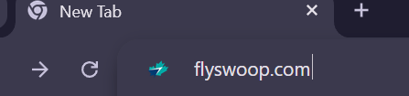

Attempting to go to [www.flyswoop.com](http://www.flyswoop.com) redirects us an article on [www.westjet.com](http://www.westjet.com) .

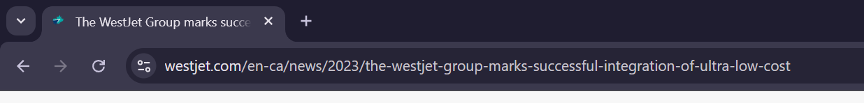

Hence, we will be only pen-testing on [www.westjet.com](http://www.westjet.com) .

## Overview

My team found a total of 0 vulnerabilities on [www.westjet.com](http://www.westjet.com) .

As for our goals, we could not meet 4 and 5 as we did not uncover any vulnerabilities as stated above.

This was mainly due to the fact that WestJet had set multiple sanitization methods in their forms, URLs among others. Moreover, the inclusion of a web application firewall (WAF) also made it difficult to find any vulnerabilities due to it detecting and denying any methods such as path traversal or cross-site scripting (XSS) from triggering.

Overall, this pen-test report has indicated WestJet’s robust security posture on securing and hardening their web application [www.westjet.com](http://www.westjet.com) via the methods mentioned above, though they should ensure they regularly update and test their security and hardening measures to ensure they are up to date with newer vulnerabilities as the years go by to ensure they are able to operate smoothly and without disruptions.

# Pentest Walkthrough

## Reconnaissance

### Nmap

Scan done on [www.westjet.com](http://www.westjet.com) to find any available services and operating systems.

From the scan done, we can see that there are two ports open, 80 and 443. The detected OS is Actiontec embedded, Linux. This suggests that the system is running a Linux-based embedded OS, most likely firmware used in network devices like wireless access points.

Moreover, it looks like Westjet is using AkamaiGhost, a web application firewall (WAF).

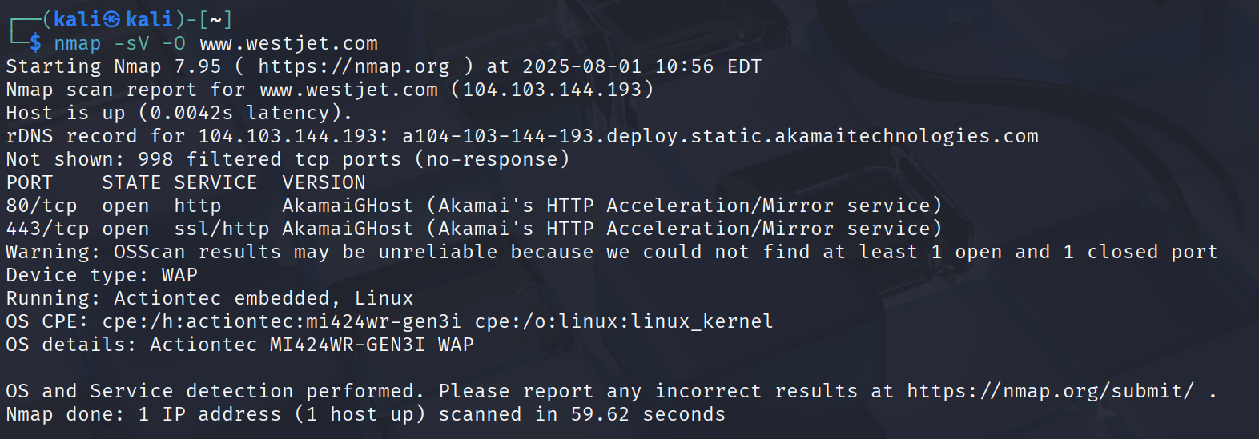

### Whatweb

A basic whatweb scan was initially conducted via the default user agent. However, it was blocked.

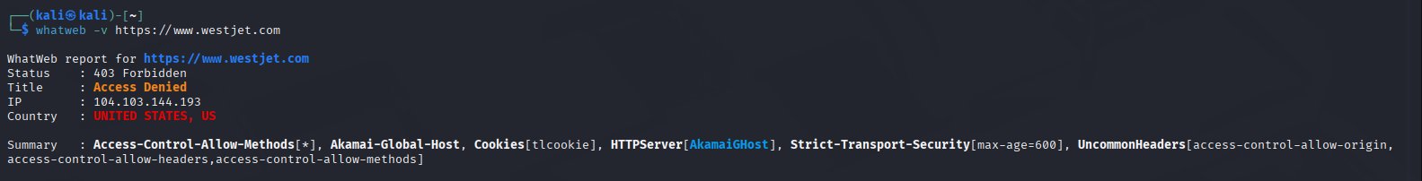

This is because the site employs Akamai WAF, which most likely blocked the scan due to its default fingerprinting behavior and non-browser user agent.

After adjusting the approach to use a spoofed browser User-Agent string, instead of using WhatWeb’s default agent, the scan was successful, and we garnered some useful info, managing to scan two sets of results. (Essentially we spoofed our User-Agent to make it seem like a real browser instead of default whatweb User-Agent that websites often block.)

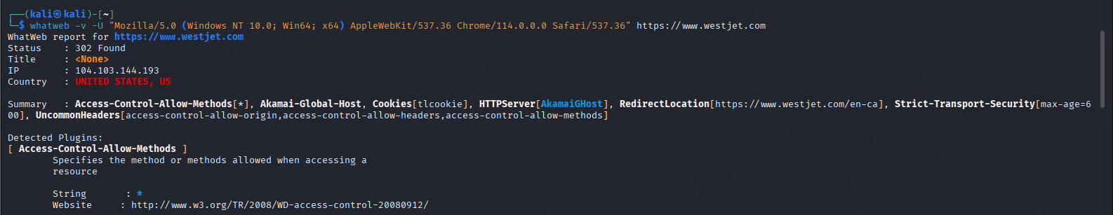

The initial request resulted in an HTTP 302 redirect to <https://www.westjet.com/en-ca> , which is the actual landing page. WhatWeb followed this redirect and retrieved detailed technology fingerprinting data from the /en-ca page, including server type, CMS, and security headers.

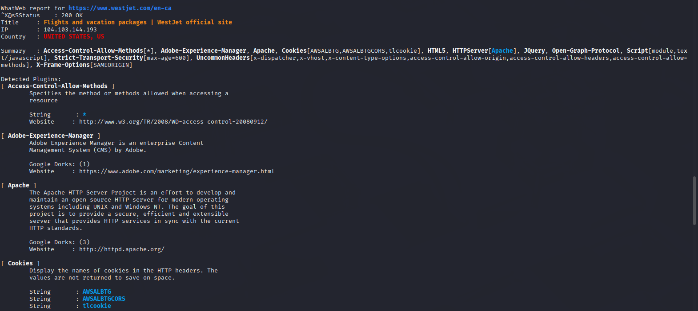

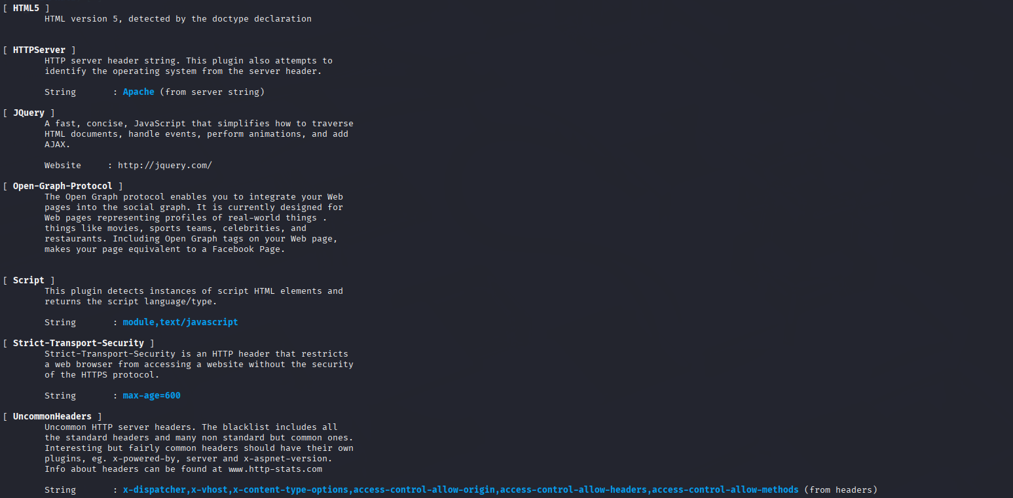

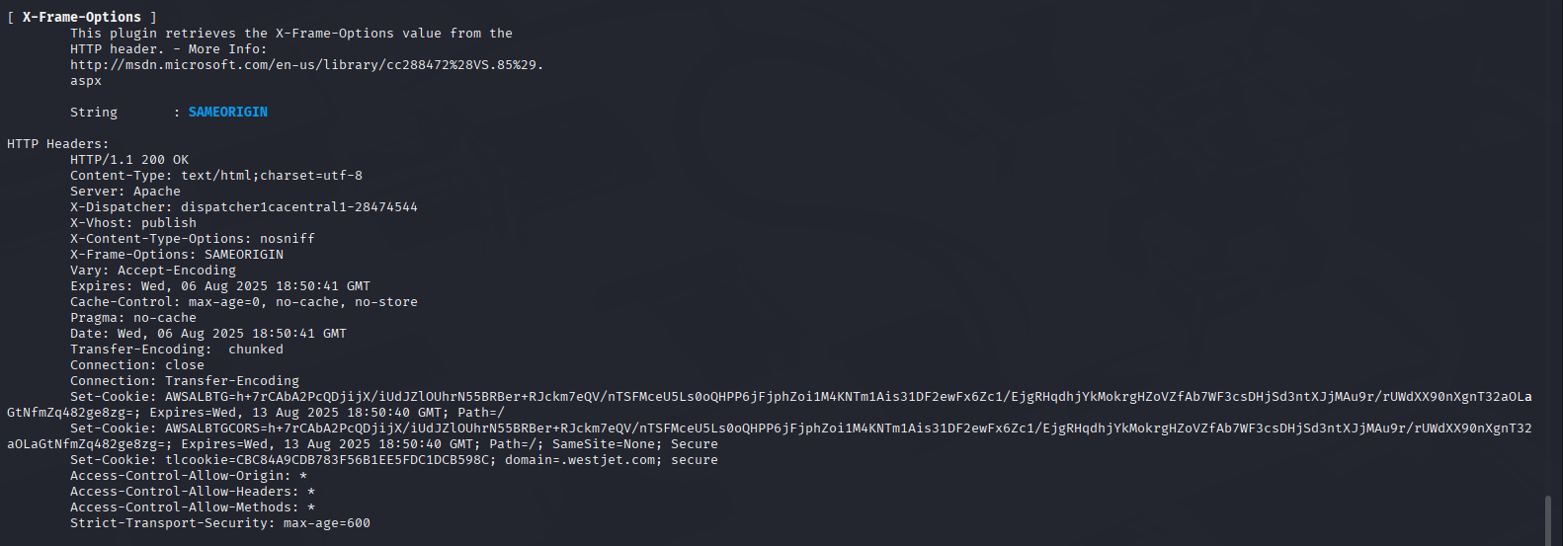

We now know the technologies running on the target.

The WhatWeb scan of <https://www.westjet.com> identified the use of the Apache web server and Adobe Experience Manager (AEM) as the site’s CMS. Several security headers were present, including Strict-Transport-Security, X-Frame-Options, and X-Content-Type-Options, indicating basic security hygiene.

1. Gobuster

We attempted to spider the page using Zaproxy on Kali VM, but the virtual machine froze due to Zaproxy using up all the memory. This is most likely due to the fact that WestJet is too extensive. Moreover, spidering is unable to find orphaned pages as they are not connected to any directories and are instead separated.

Thus, we will be performing directory enumeration using Gobuster, where will use a pre-defined word list containing several common words to enumerate for any directories or orphaned pages.

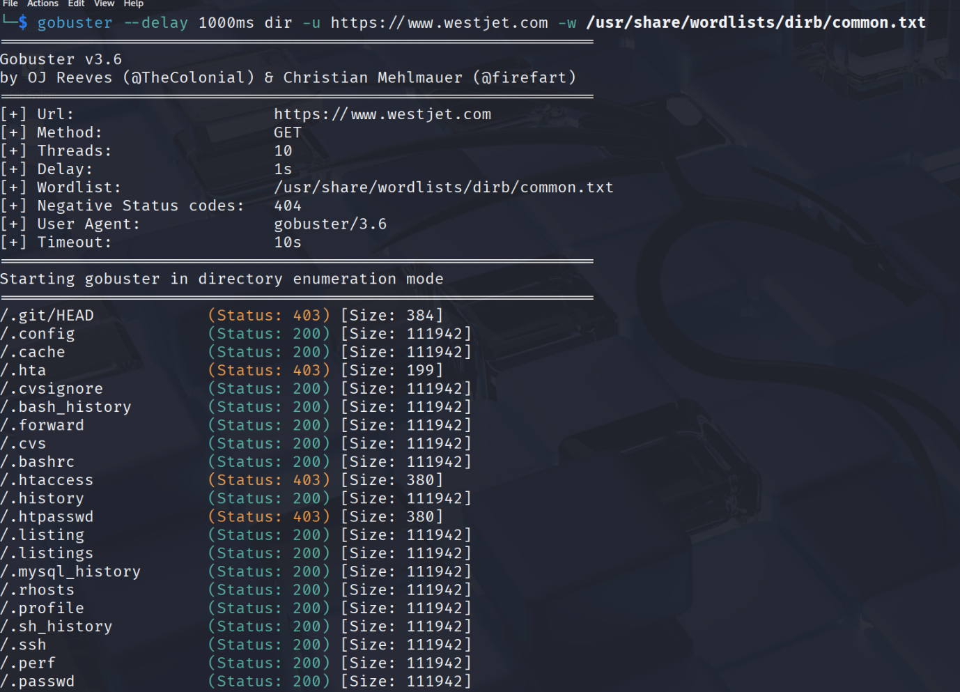

As seen above, we are enumerating for potential directories or orphaned pages on [www.westjet.com](http://www.westjet.com) using Kali VM’s provided wordlist in the dirb directory to perform directory enumeration with Gobuster, as well as rate throttling the requests to prevent potential IP banning by the WAF.

The raw outputs of Gobuster will be in the appendix, and we will be showing only relevant screenshots of Gobuster’s output when necessary in the report.

### Amass

We ran Amass to find subdomains of [www.westjet.com](https://www.westjet.com/) to find any hidden assets or subdomains we shouldn’t see. Upon finding the various subdomains, we can try to access a handful of them to find any pages of interest. There were 2 types of scans performed, active and passive.

The first one was a passive scan

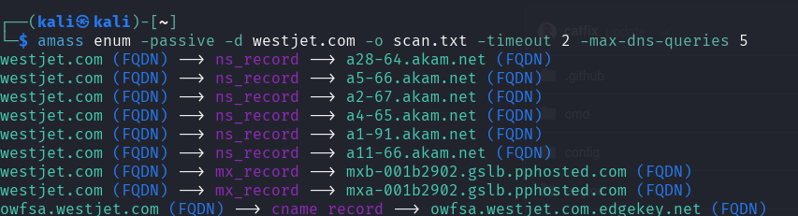

And this is for the active scan

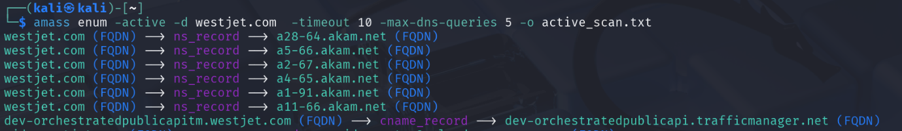

We throttled it by using the arguments -*timeout* and –*max-dns-queries. -timeout* sets a maximum time we are allowed to run the enumeration process. *-max-dns-queries* is to set the maximum number of dns queries Amass is allowed to send per second because by default, amass will send 100 dns request to the target website per second. This goes against the scope of the pentest.

After visiting most of the subdomains found, we concluded that a large number of them either don’t exist, can only be accessed using a staff email, or we are given a 403 forbidden message.

The full scan details can be found in the appendix.

There was this site <https://uat.pay.westjet.com/hw2web/landing.xhtml> that seemed to be interesting, you cannot access it using your WestJet rewards account and you can’t activate your account by inserting your WestJet account’s email address. It is likely that UAT stands for User Acceptance Testing, where the company ensures that their software application meets the client’s needs and helps to uncover bugs. Inside the URL there was a field called LoginID, which had our email we placed earlier when we clicked sign in. However, when we changed it to an official WestJet email address ([privacy@westjet.com](mailto:privacy@westjet.com)), it did nothing.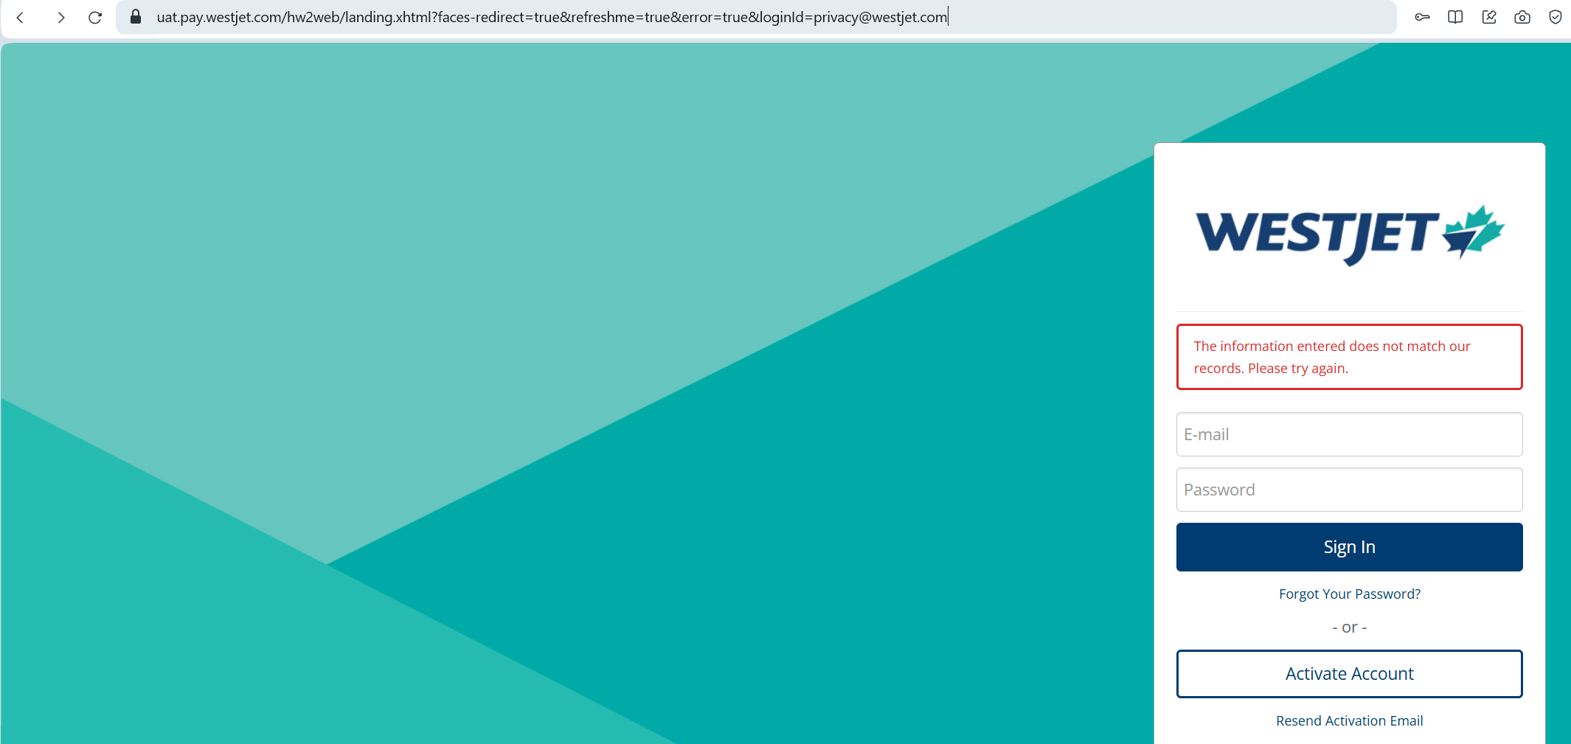

#### Conclusion

All in all, there was strong access control and attack surface management to ensure limited accessibility for all unauthorised users. An example that shows this is the User Acceptance Testing (UAT) site, which is sensitive, was kept private. A strong security posture was demonstrated by ensuring that these subdomains mostly do not give unauthorised users insights into how the website operates.

A recommendation would be to continue this strict access control and network segmentation for assets that should be kept behind closed doors. In addition, there should be a monitoring program to ensure that in the future, all subdomains do not become too over-exposed, compromising the company.

As such, we should remain aware that important and sensitive environments like UAT and staff portals should never be exposed without strict authentication. Regular scans and audits ought to be conducted by team members, and continuous validation to ensure only authorised accounts can access assets should be performed in future deployments.

This reinforces the importance of consistent secure coding and defensive configuration across the whole application. It reminds us that sensitive environments such as UAT, staging, and staff portals ought to remain strictly internal, and teams should be aware of the risks of exposing said environments. A solid understanding of how attackers search for and probe subdomains will assist in spotting similar risks during the setup of new devices. Confirmation that all internal endpoints require authentication should be made a habit during development, to ensure that no test environments are left accessible to the public.

Additionally, this extensive access control shows that WestJet is dedicated to complying to the meeting industry standards such as PCI DSS, GDPR, and ISO 27001, which mandate strict restrictions on who can view or modify sensitive data. By enforcing strict authentications and authorization, WestJet can prevent unauthorized access to protected data, which will reduce the risk of data breach and maintain consumer trust.

## Exploitation

### Cross-Site Scripting (XSS)

#### Testing inputs manually using Burp Suite:

When experimenting with the website, we encounter the pricepoints/flight price calendar API.

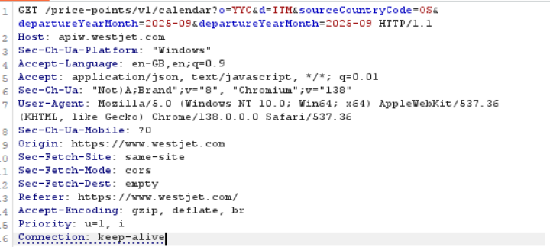

Upon messing around with the departureYearMonth parameter:   
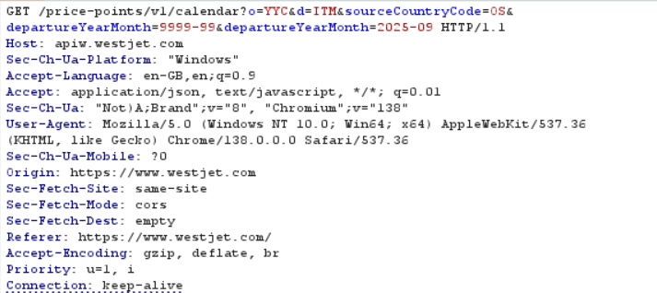

The request was rejected due to an invalid input as shown below.

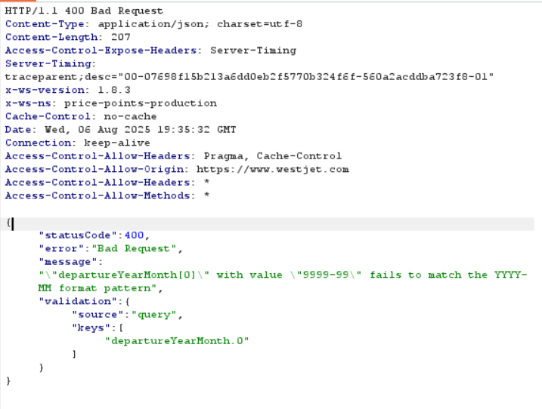

The above results are the same/similar as the results given when trying to input invalid formats, special characters, and empty values.

Attempting to XSS:  
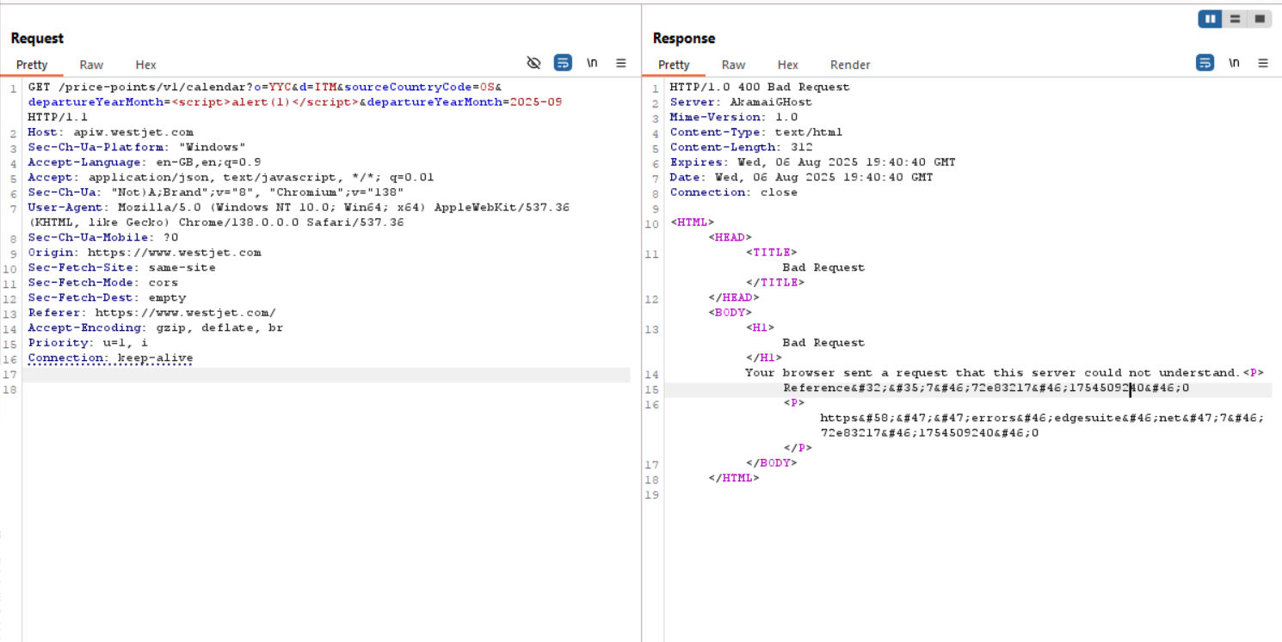

The request did not reach the WestJet backend API, as the Akamai WAF blocked it early due to malformed or suspicious input. This shows that the WAF layer is filtering potentially basic malicious input. Inputting the same <script>alert(‘x”)</script> in other parameters did not work either.

Attempting with less obvious payloads:

("><svg/onload=alert(1)>)  
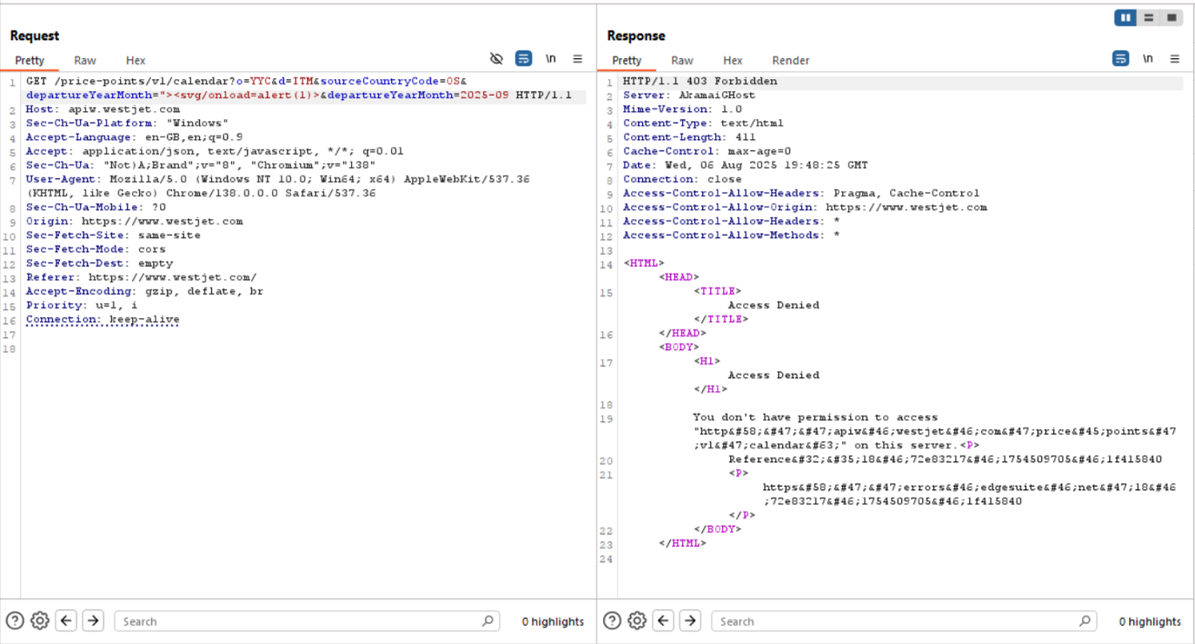

A full list of the payloads used are in the appendix, but they all yielded the same results.

We also decided to conduct XSS on a separate page. From the WestJet > Vacations tab, we can attempt to book a vacation package. Upon being prompted to enter our guest information details, we can capture the HTTP POST request packet. Within the packet, it contains your details and contact information.

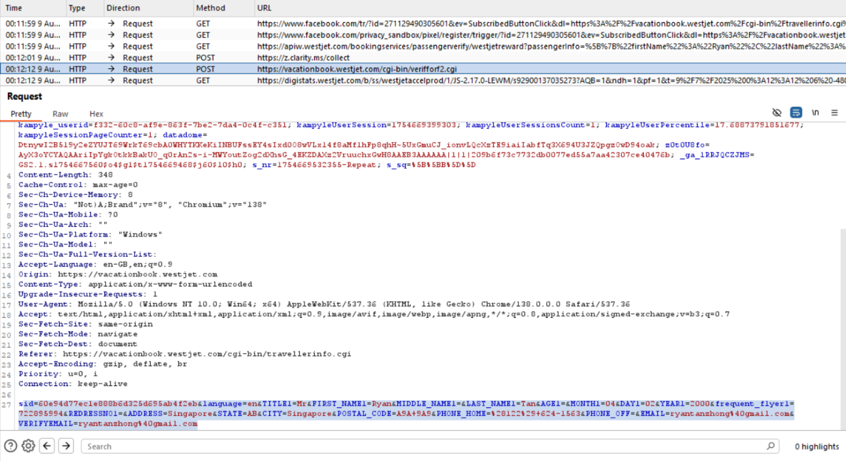

Upon sending this request to intruder, and using a set xss payload list via the battering ram, we can see the response output below

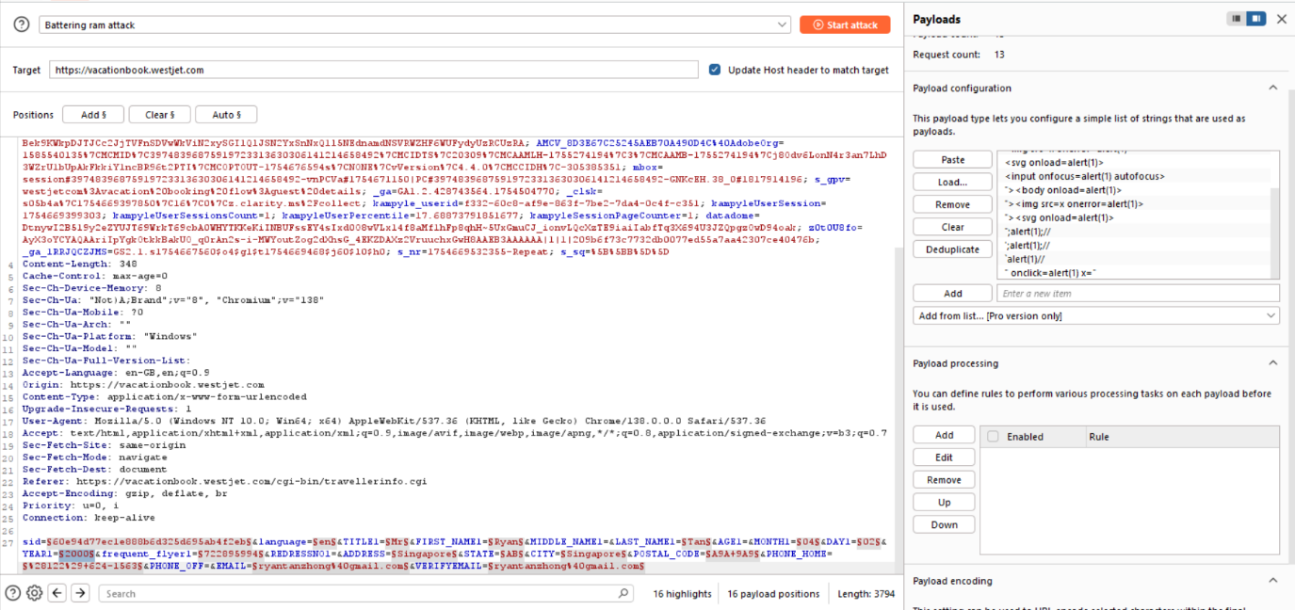

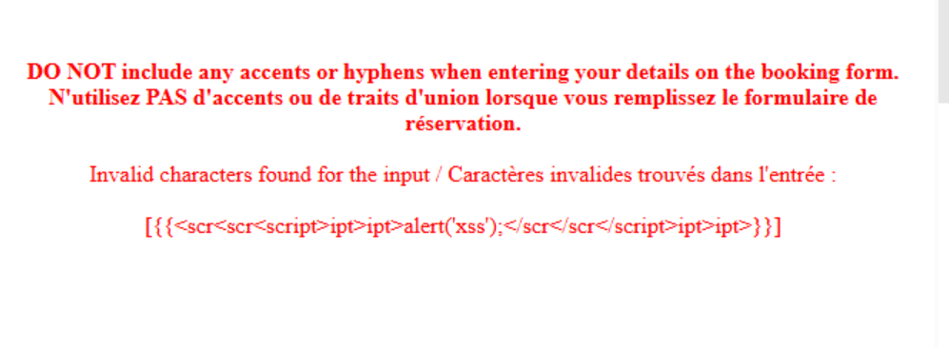

User input was observed being submitted via a POST request to /verifforf2.cgi. While testing for common input injection vectors, no reflected or DOM-based XSS was observed, and input appeared to be properly sanitized.

#### Attempting to perform XSS payloads on vacationbookings.westjet.com subdomain

To first access the subdomain, we will need to search for our vacation bookings in the ‘/manage/vacations’ directory shown below.

Gobuster could not find this directory, as most likely ‘vacations’ was not in the wordlist (as seen in Appendix).

As such, this directory was found through manual search.

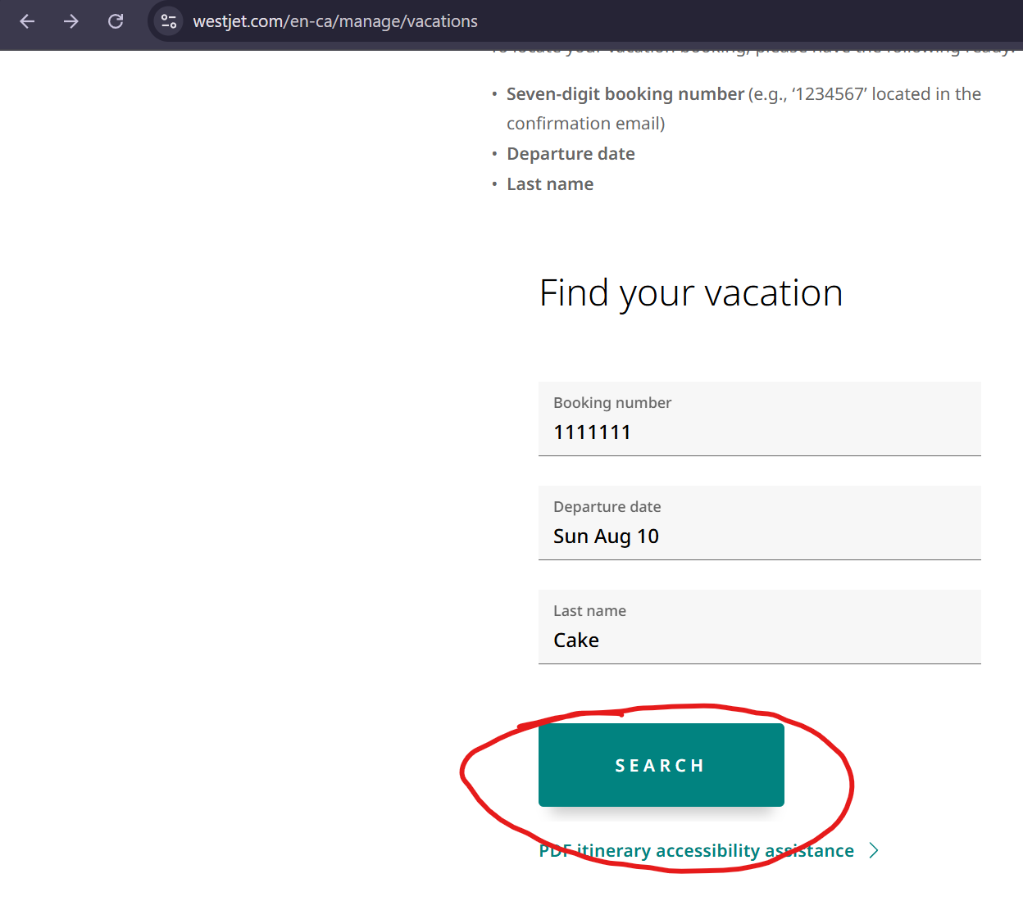

Clicking on the button on the ‘/manage/vacations’ directory will bring us to the subdomain ‘vacationbookings.westjet.com’.



Interestingly, we are brought to a subdomain of [www.westjet.com](http://www.westjet.com) that has URL parameters we can potentially exploit, alongside an error message.

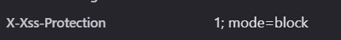

However, under Headers in Inspect > Network, XSS is blocked on the page due to the ‘X-Xss-Protection’ header, meaning we will be unable to trigger any XSS and hence the page is not vulnerable to it.

As a result, we will not perform any XSS on this subdomain.

#### Attempting to perform XSS on ‘/manage/dashboard’



As seen above, there is a URL parameter ‘sessionId’ that we can perform XSS on and there are no headers such as CSP or X-Xss-Protection that could potentially deny it. Hence, we will be testing some payloads by KhanJanny. The links to the used payloads will be under appendix.



The above circled payload attempts to load an image that does not exist, which would result in an error that would create a prompt ‘/OPENBUGBOUNTY/’. Some words are intentionally capitalised as WestJet’s website input sanitisation could be case sensitive, which may hence let the payload through. The already existing value of sessionId is kept to ensure it does not cause the website to break.

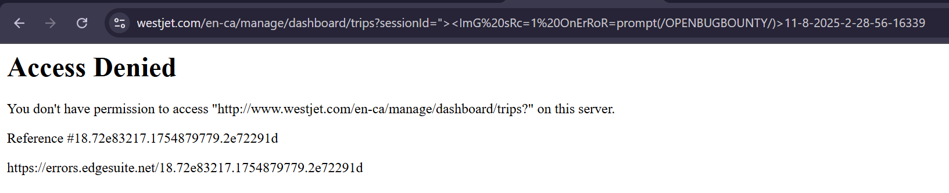

Unfortunately, we are met with a 403 Forbidden error, suggesting that WestJet’s input sanitisation is not case sensitive and was able to detect the XSS payload.

The other 2 payloads under appendix were also attempted, though they also yielded the same results.

#### Conclusion

Overall, WestJet has implemented proper security measures to prevent XSS via the use of headers, escaping inputs as text content, proper input sanitisation and the use of a WAF to detect any XSS attempts, even if encoded, obfuscated or otherwise.

Moreover, by not having any user content be viewable from other users, it actively prevents stored XSS, which works by storing malicious payloads in user profiles or forums which would trigger when the user accesses that page.

In addition, by escaping inputs, it ensures DOM XSS cannot be triggered as it would be text content. By monitoring URL parameters for any malicious payloads, it also prevents reflected XSS.

This is expected as according to OWASP, it is the 3rd highest vulnerability among the top 10 in 2021.

Hence, this ensures cookies of users on WestJet cannot be stolen by malicious actors, which thus prevents their sessions from being hijacked by them by ways such as an XSS payload that could leak an administrator’s cookies to an attacker’s server, providing them administrative privileges and hence access to the ‘/administrator’ directory, which could allow an attacker to delete, hijack or exfiltrate users and/or their data.

As a result, this would cause damages to WestJet due to a loss in trust between consumers and the company, which would in turn cause a loss of revenue as consumers choose other more secure flight websites such as Singapore Airlines.

Hence, WestJet’s operations are able to run smoothly without any user cookies from getting leaked, preventing any form of session hijacking from malicious actors.

From this, it ensures confidentiality and integrity of the customer’s data and cookies.

Since the security controls in place are effective, a recommendation is that WestJet continues to enforce or even strengthen the input sanitation measures across the whole site. Another suggestion is to implement a Software Composition Analysis (SCA) tool, a tool to scan for vulnerabilities in any 3rd party software. This takes on a more preventative than reactive approach.

The takeaway is that when building or reviewing code, members/teams ought to think about how data from the user flows through the application and identify where attackers might try to insert malicious scripts. Developing an instinct to question oneself: “What happens if this input is manipulated?” Will help us spot XSS risks before they reach production. It is also worth noting that defence in depth is effective, but only if every layer is applied consistently.

This also displays that WestJet has a high amount of compliance with industry standards, as there is little to no chance that a DOM or reflected XSS attack will cause the leakage of important or sensitive customer information to any malicious attacker, meaning it complies with personal data compliance standards like GDPR in the EU and the Data Protection Act in the UK. As XSS is rated as one of the most dangerous types of vulnerabilities that can affect a site by the OWASP Top Ten, this shows that WestJet is properly protecting its pages against major vulnerabilities and will not be vulnerable to many attacks.

### Broken Access Control

#### Login page

When viewing the WestJet account as seen below, there is a 9-digit ID given to each account (in this case, it is 722 426 235).

This could be potentially exploited as an attacker could enumerate through IDs from

000 000 001 to 999 999 999 to potentially find valid account IDs, and then brute force and gain unauthorised access to them using cracked passwords.

However, we will not be performing brute force as it could potentially cause DoS and degrade the user experience, which is out of our scope.

In addition, it also requires permission from WestJet which we do not have.

As such, we will be only performing manual tests shown in the screenshot after to view and analyse the given error message.

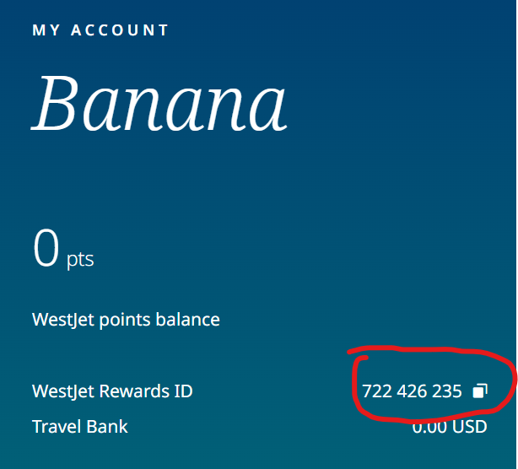

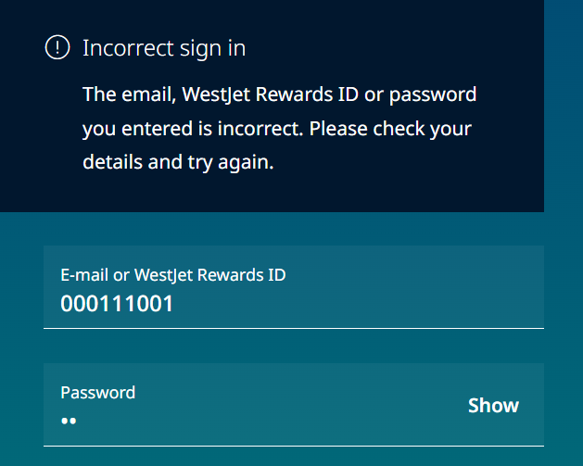

As seen above, the error message given is vague, as we do not know which input field is incorrect (ID or password).

We will be analysing the error message again using a known ID (722 426 235) to see if there are any changes made to it.

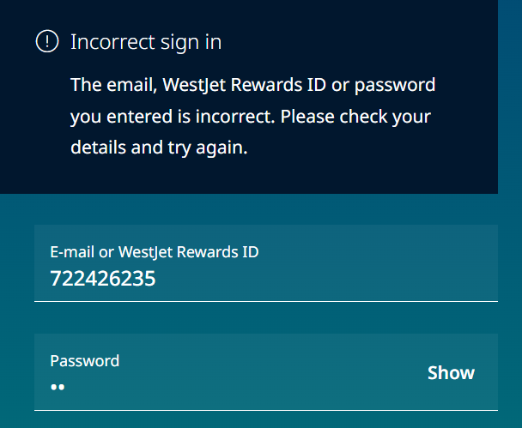

Again, it gives the same error message as before.

By giving a vague error message, it ensures attackers cannot test for a valid ID first using Burp Suite’s intruder for example, then a valid password after finding a valid ID to gain unauthorised access to a user account.

#### Attempting to gain access to the administrator panel

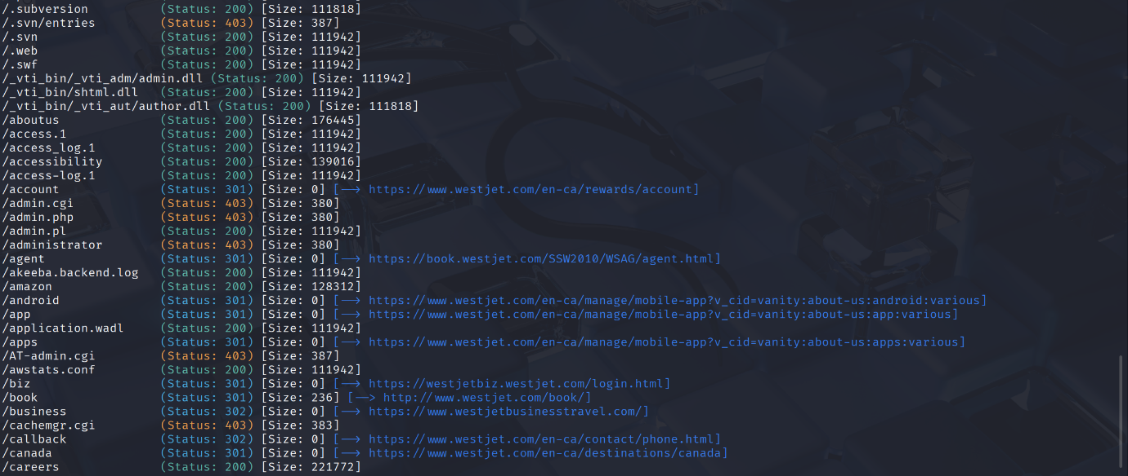



From Gobuster’s directory enumeration in the appendix, we can see that we have found the ‘/administrator’ directory of [www.westjet.com](http://www.westjet.com) .

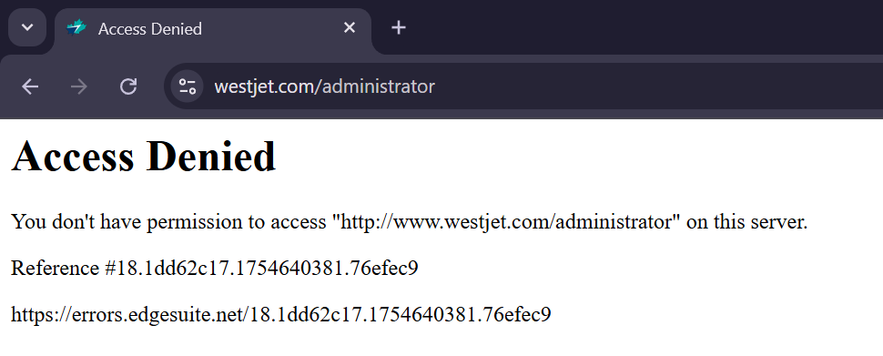

Attempting to access it gives us a 403 forbidden error as expected as we do not have an administrator account.

Moreover, there is/are no parameter(s) in the URL shown above to exploit IDORs to potentially gain access to an administrator’s account such as ‘ID’ or ‘UserId’ for example.

We will be attempting to bypass this and gain access to the administrator panel using Burp Suite’s proxy to intercept the request, sending it to the Repeater to modify and send the request in the same session.

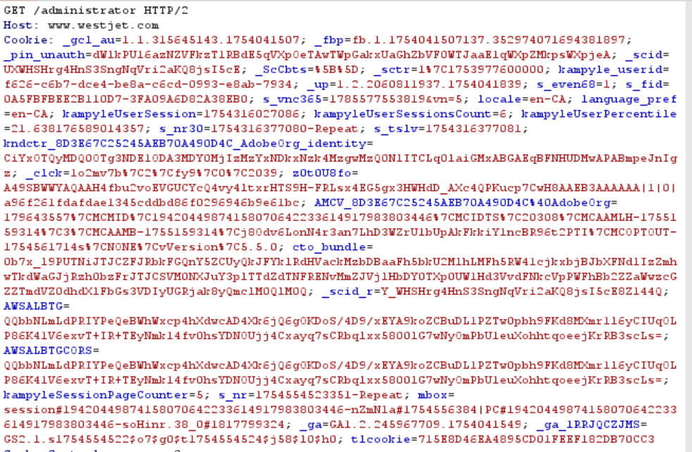

As seen above, the cookie contains many parameters, whereby most of the values are encoded in hexadecimal.

We will be first experimenting with various requests (POST,TRACE etc) to see how the server responds to such requests, potentially giving us a 200 Success response.

OPTIONS will not be used as its main use is to request the server for permitted communication request options for a request and hence will not provide us with any valuable information.

DELETE will not be used as we do not want to accidentally delete the /administrator directory.

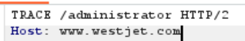

We will append the GET to TRACE and send the request, which may cause the server to disclose confidential information such as internal authentication headers or cookies as a result to us, which we can use to perform further exploitation.

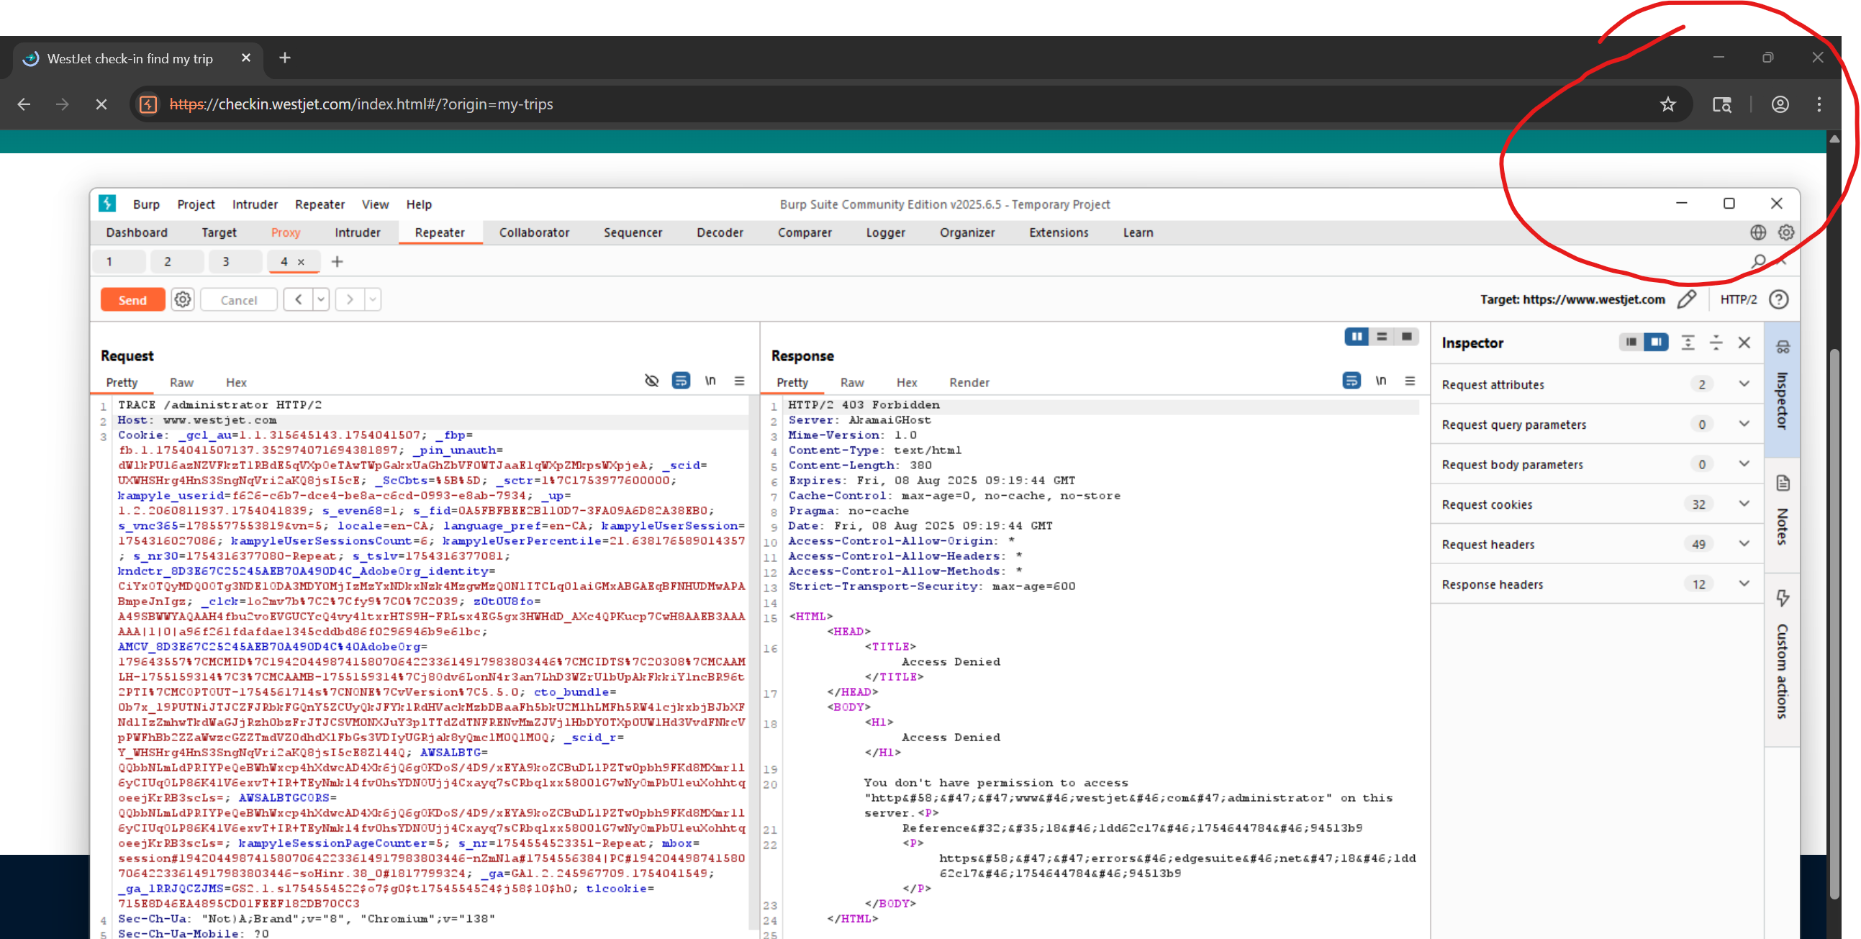

As seen, the server did not leak any information to us after sending the request, meaning the TRACE request is potentially blocked or disabled by the WAF or headers.

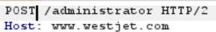

This time, we will append the request to be POST, whereby we will attempt to submit the request instead of requesting it.

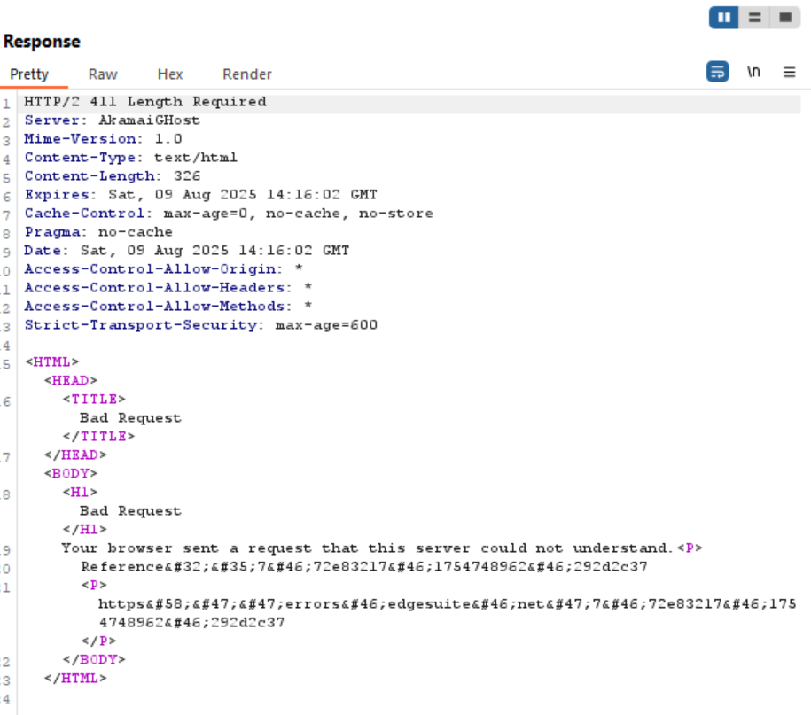

As seen above, we get a 411 Length Required error, meaning the server did not process the request due to the lack of a Content-Length header.

We will try with PUT, which attempts to create a resource from the given request.

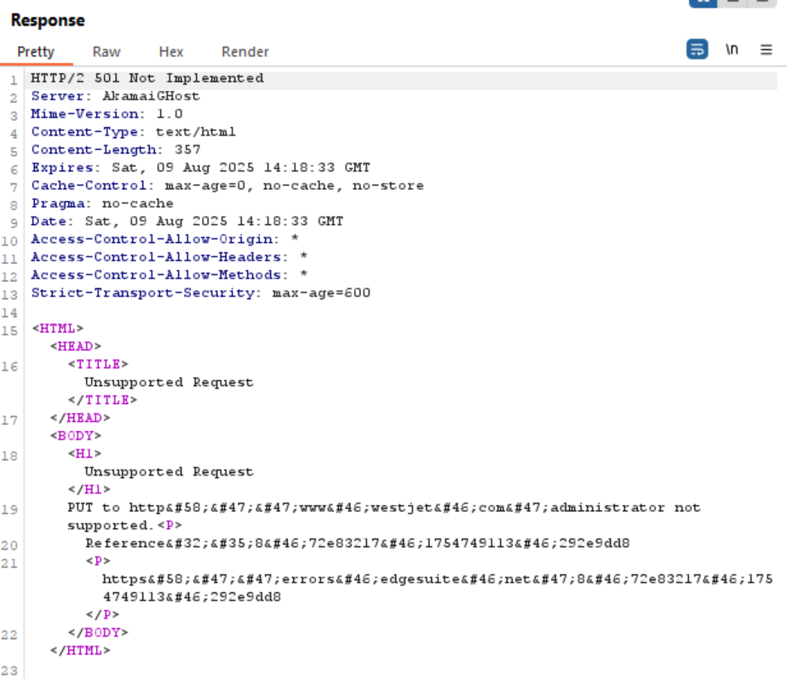

As seen above, a 501 Not Implemented error is given, meaning that the /administrator directory does not support PUT requests.

The other requests (CONNECT, HEAD, PATCH) also did not give a 200 Success response after pen-testing.

Gobuster was unable to enumerate for further directories within the /administrator directory as it was denied by the WAF due to inadequate permissions, hence we cannot also use a Referer (for example, /administrator/deleteUser) to potentially gain unauthorised access to the administrator panel as we do not know what potential subdirectories there are.

Robots.txt also did not leak the /administrator directory and further subdirectories.

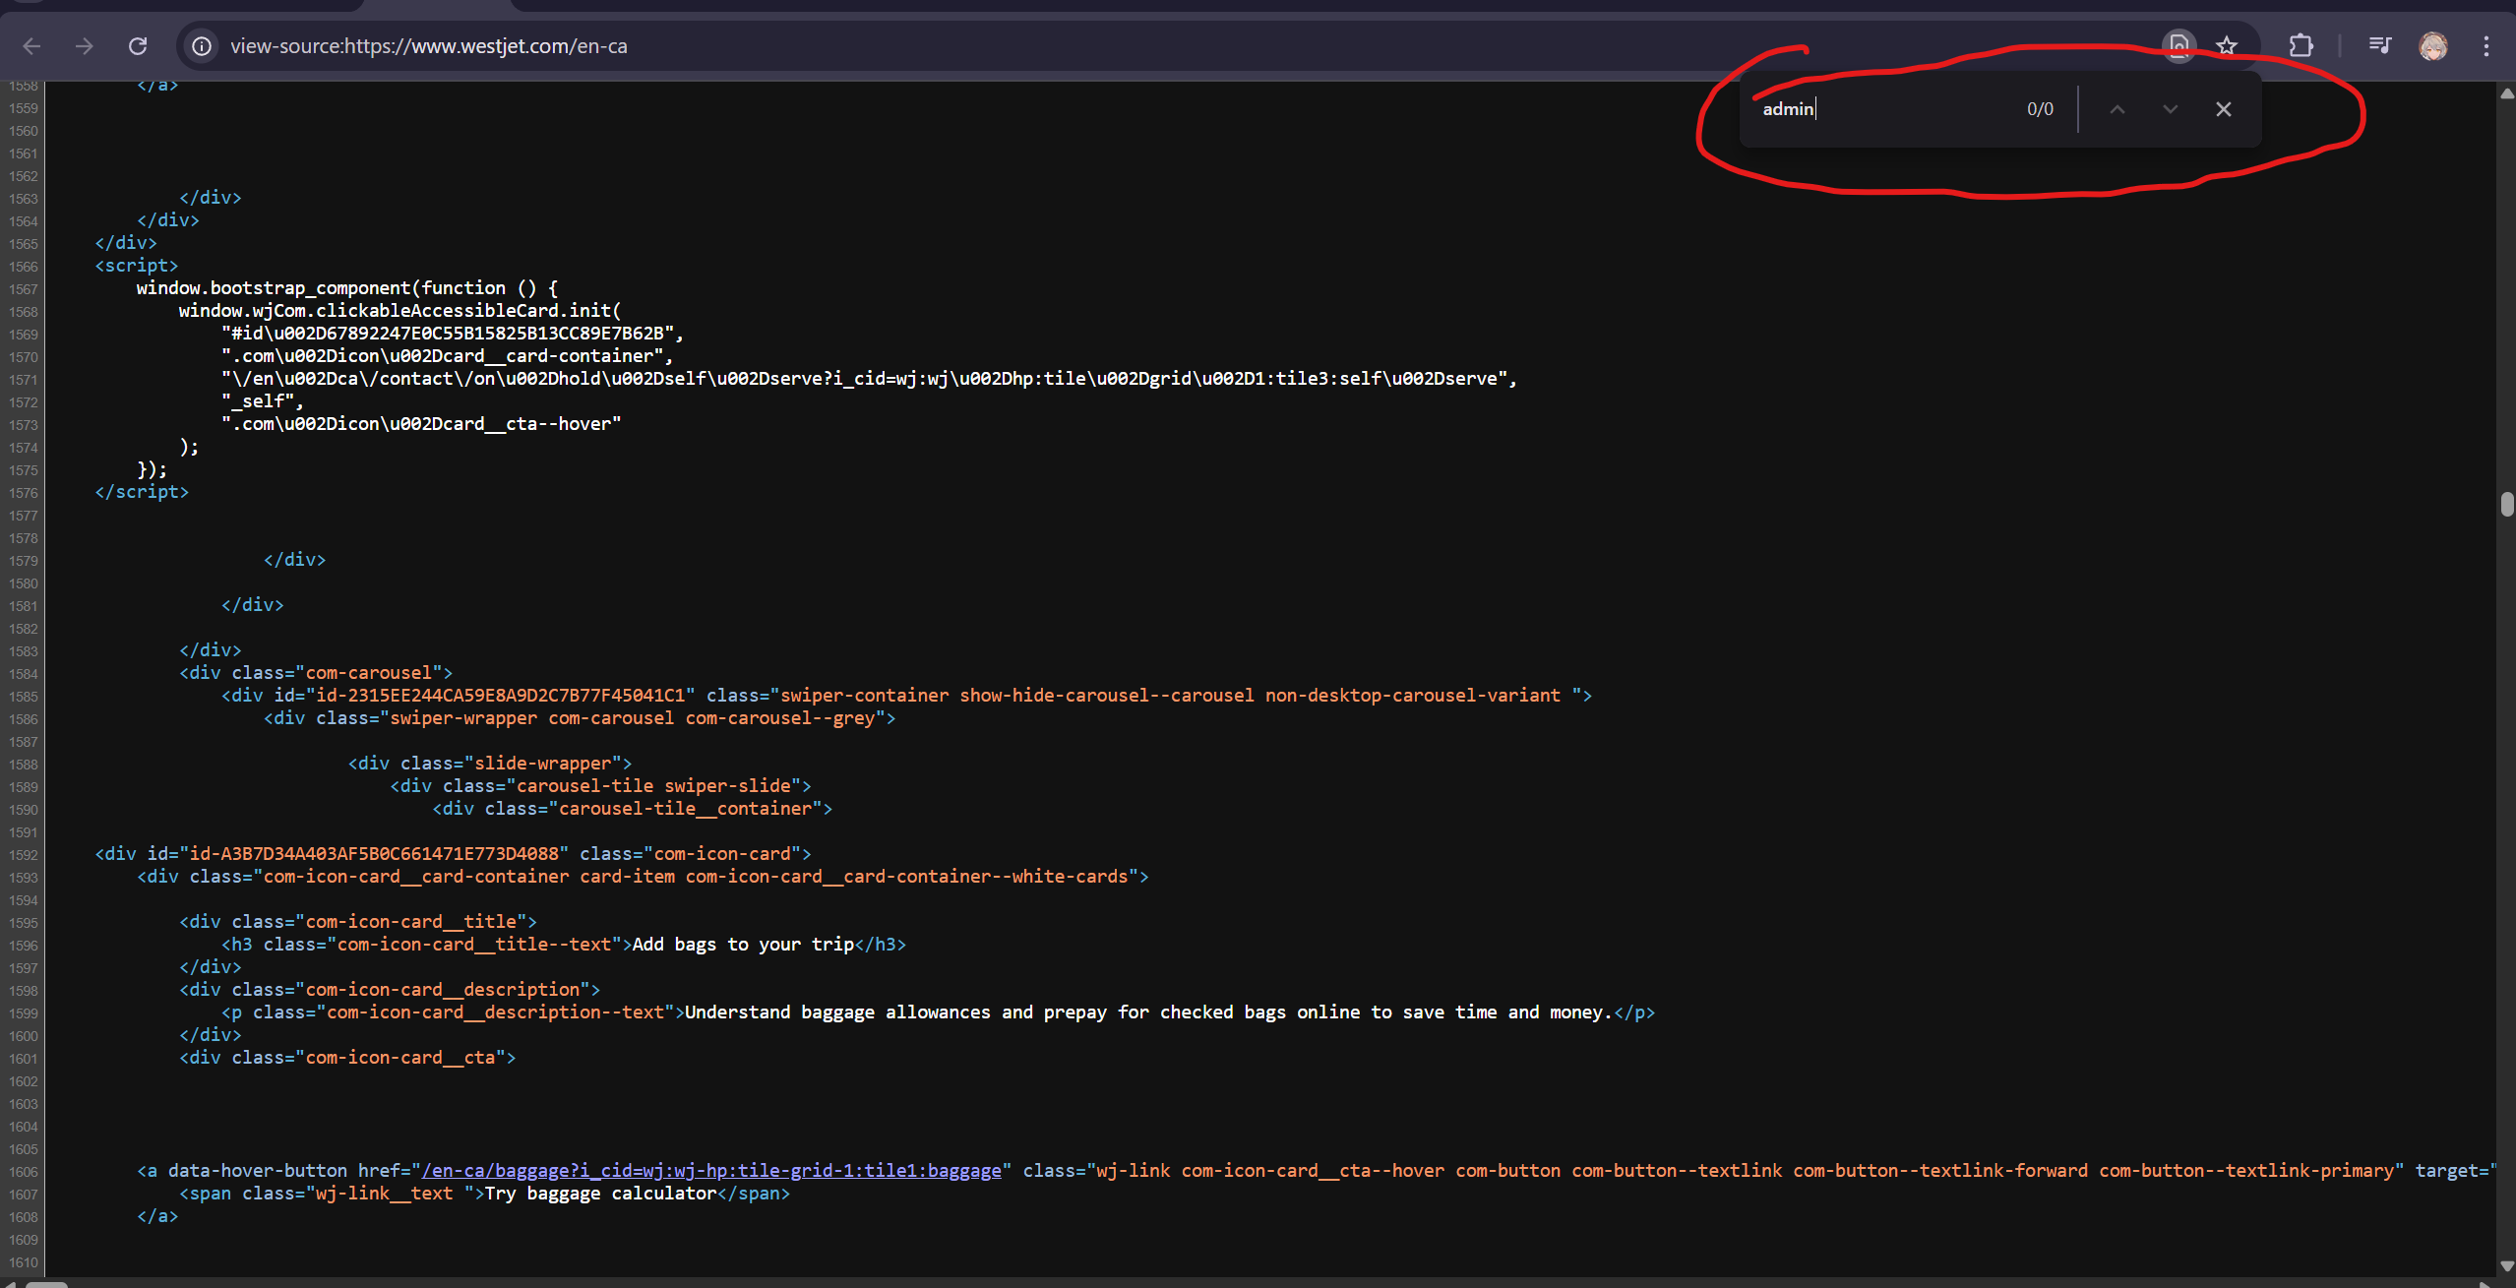

Moreover, the front-end code also does not leak any information on how to access the administrator panel as seen above on the home page, whereby the ‘Find’ function on Google Chrome was used to search for any mentions of ‘admin’, in which it found none.

#### Conclusion

Overall, WestJet has implemented many security measures against broken access control vulnerability such as vague error messages, no exploitable parameters in the URL such as ID, proper safeguards against tempering of request options (PUT, POST etc) and the use of a WAF.

This is expected as according to OWASP, it is the number 1 vulnerability among the top 10 in 2021.

This ensures users and/or their data would not get deleted, hijacked or exfiltrated by malicious actors that gained unauthorised access to user accounts or ‘/administrator’ directory, which could hurt WestJet as a result due to a lost in trust between consumers and the company, causing a loss of revenue as consumers choose other more secure and trustable airlines such as Singapore Airlines.

Hence, these implementations allow WestJet to operate freely without any worry of cases of unauthorised access to the administrator panel.

The controls which prevented these access attempts (Error messages, restricted HTTP methods, no exploitable parameters) all came from conscious design choices. This reinforces that fact that seemingly small detail such as how an error is phrased can have a big impact on security. Teams should make it second nature to check if a feature could potentially give away more information that it should and consider what happens should someone try to bypass the front-end and talk directly to the backend – and implement the relevant countermeasures.

Although it is secure on the front end, the back end may not be. We recommend performing internal audits to ensure that the principle of least privilege is strictly adhered to prevent any accidental information leakage or exploited by internal threat actors.

This practice of ensuring that no data can be found on how to access the administrator panel within the frontend minimizes the risk of an attacker being able to gain admin privileges, which would likely allow them to access all of WestJet’s server data, leading to massive information leakage. This displays data compliance with multiple data standards in different regions, ensuring that WestJet does not put its customers and their data at risk.

### SQL Injection

Note: We will not be increasing the risk of SQLmap (defaulted to 1), to ensure we do not cause any potential modifications to data in WestJet’s database.

#### Checking for SQL vulnerabilities on login page

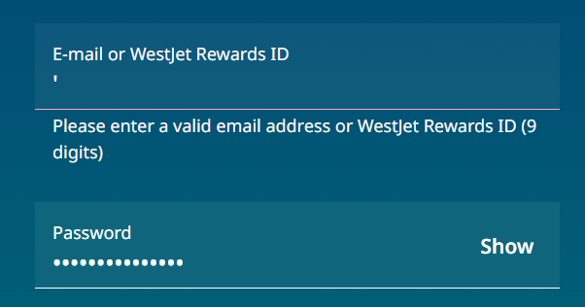

As seen above, attempting to add ‘ causes an error message to be made asking for a valid email or ID.



Viewing the front-end code using Inspect reveals to us that the text field type is text, but it wants either an email address or 9-digit ID, meaning that it potentially sanitises the input from the server-side (back-end code).

Hence, we will be unable to edit the front-end code to allow for malicious inputs.

Performing SQL injection on /manage/check-in directory

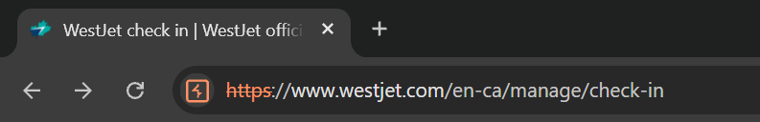

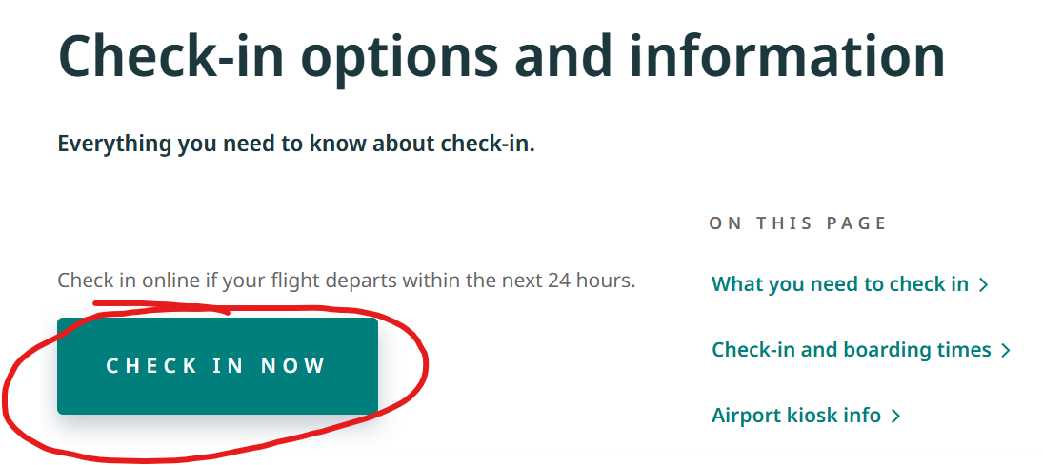

Clicking on the button in Burp Suite’s Chromium browser with Intercept turned on will allow us to intercept the requests made.

We are doing this to save the desired request URLs as files to make it more convenient for us, as sqlmap allows HTTP request files to be used for SQL injection instead of a URL and cookie.

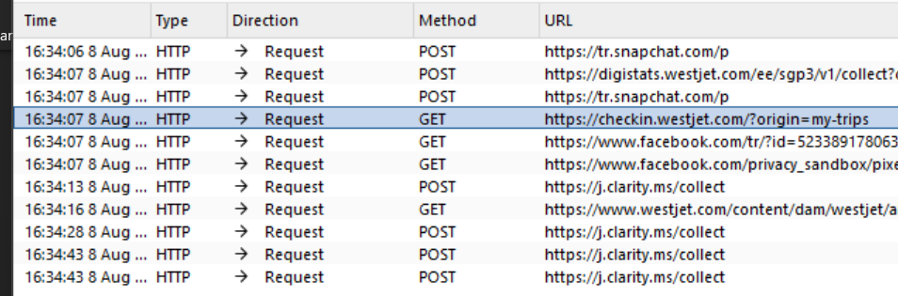

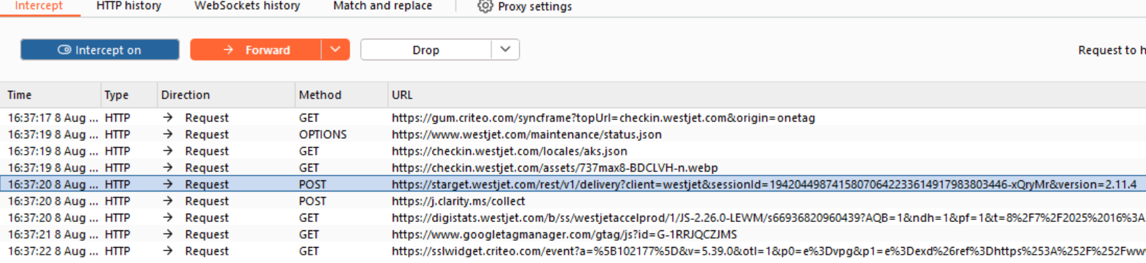

Save these 2 URLs as items (.txt file extension) in HTTP history and copy them to the Kali VM.

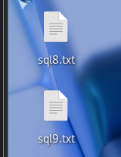





We will be performing rate throttling to ensure we do not get IP banned by the WAF and we do not cause any potential Denial-of-Service (DoS) from sending too many requests at once.

Moreover, we will only dump table names using --dbs as it is out of scope to exfiltrate live client data.

The ‘--random-agent’ argument means sqlmap will use a valid user-agent (Google Chrome, Firefox, Safari etc) to not get blocked by the WAF.

sql8.txt:



sql9.txt:



As seen above, sqlmap was unable to inject or found no results from the HTTP requests in the files, most likely due to the requests being too simple.

We will be attempting to increase the level using ‘--level’ argument to increase the complexity of the requests, which hence may yield results.









sqlmap still yielded no results from both HTTP request files even with the level increased to 3, with sql8.txt giving error 400 (Bad Request).

We will be doing it again with level 5, the maxed level.

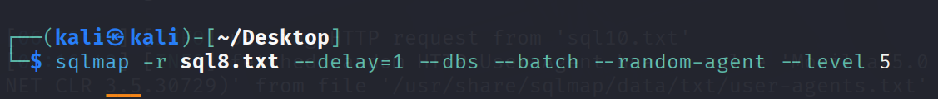









Unfortunately, sqlmap still yielded no results from both HTTP request files, even when the level of requests was maxed out, meaning these 2 endpoints are not vulnerable to SQL Injection.

We will be attempting another SQL injection on another directory in ‘/manage’.

#### Performing SQL Injection on vacationbookings.westjet.com subdomain

To first access the subdomain, we will need to search for our vacation bookings in the ‘/manage/vacations’ directory shown below.



Clicking on the button will bring us to the following page.



Interestingly, we are brought to a subdomain of [www.westjet.com](http://www.westjet.com) that has URL parameters we can potentially exploit, alongside an error message.

We will be using Burp Suite’s Chromium browser to intercept this request, save it as an item and copy it to our Kali VM for SQL injection.

. 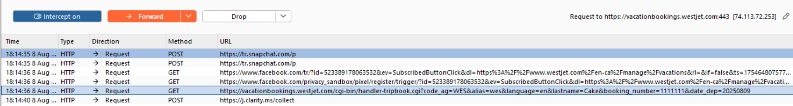

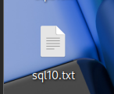



We will use the same parameters as before, this time directly skipping to level 3.





No results could be garnered from sqlmap, with the server giving a 418 error response (Teapot), which means that it did not want to handle automated queries from sqlmap.

From this, we are able to garner that WestJet has made the above forms not susceptible to SQL injection, possibly through sanitised inputs or parameterised queries.

#### Conclusion

Overall, WestJet has implemented multiple security measures to prevent SQL injection through potential methods such as parameterised queries and input sanitisation.

This is again expected as it is the 3rd highest vulnerability in OWASP top 10 in 2021.

These measures ensure malicious actors cannot exfiltrate/dump data of WestJet’s employees and users such as passwords, emails, credit card details among others, leading to data breaches as it would allow them to gain unauthorised access to confidential information that they could use to compromise a user’s other accounts such as their Google account, alongside financial gain via the dumping of credit card details.

As a result, this would cause a huge breach in trust between consumers/employees and WestJet, leading to losses in customer/employee loyalty and negative media coverage that in turn could result in a huge blow to WestJet’s brand in terms of financial losses via costs or legal liabilities.

Thus, the measures implemented ensures WestJet can operate uninterrupted without any worry of data getting dumped and leaked, which would lead to the consequences mentioned above.

WestJet has marvellous SQL injection countermeasures; however, we recommend one upping by adjusting the user privileges in such a way that the database service account only has the bare minimum privilege needed for it to function. For example, there should be no reason for a vacationbookings.westjet.com subdomain to have table-dropping rights if all it needs to do is to fetch vacations.

Having a solid understanding of how SQL injections work and why certain coding patterns are safer, instead of simply trusting that a framework will take care of it - which is shoddy development. As Developers/Engineers, recognizing SQL injection patterns during design/peer reviews can reduce the chances of ever introducing them in the first place. Building such awareness into daily development is key to keep injection risks low.

The application’s resilience against SQL injection attacks also demonstrates WestJet’s commitment to protecting sensitive data and maintaining compliance with relevant data protection standards across multiple regions, with virtually zero chance that any customer data would be at risk of leakage.

1. Path Traversal

#### Performing path traversal and absolute path on ‘/manage/dashboard’ directory



As seen above, the directory has a parameter we can exploit path traversal on which is ‘sessionId’.

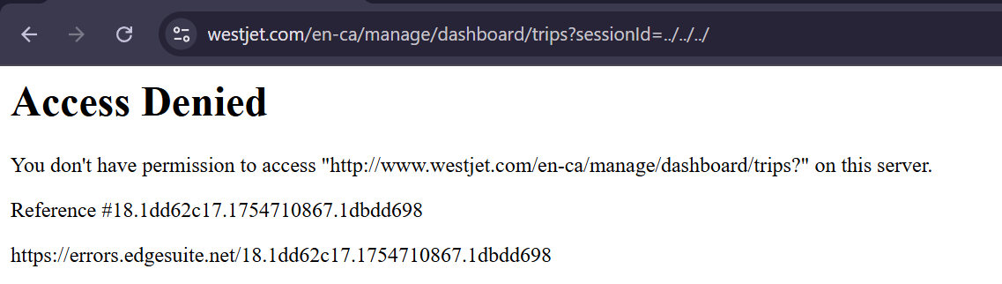

Attempting to perform path traversal using ‘../../../’ leads to a 403 forbidden error given.

We will attempt to access the ‘/etc/passwd’ directory via an absolute path, as from our recon, we know that the OS is Linux, meaning that this directory should exist.

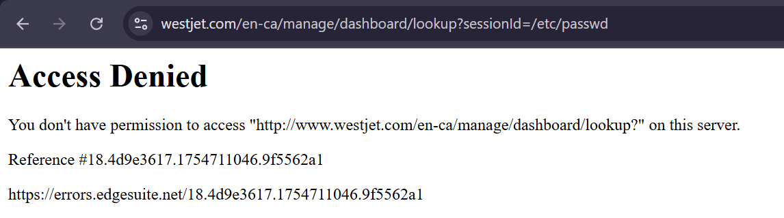

Again, it still leads to a 403 forbidden error.

This could potentially be that the WAF uses a match condition to check if the parameter has ‘…/…/’ or ‘/etc/passwd’ for example.

Hence, encoding these may result in us bypassing the WAF and getting a 200 Success response instead.

The encoded variations are provided by OWASP and will be linked under Appendix.

‘%2e%2e%2f%2e%2e%2f’ is the encoded version of ‘../../’, which we will be testing out again.

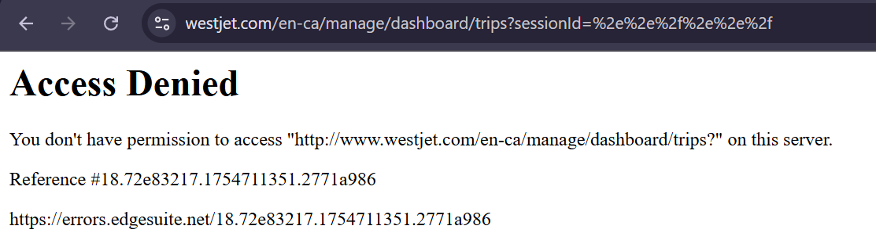

Again, it still leads to a 403 forbidden error.

We will be attempting ‘%2fetc%2fpasswd’ which is the encoded version of ‘/etc/passwd’.

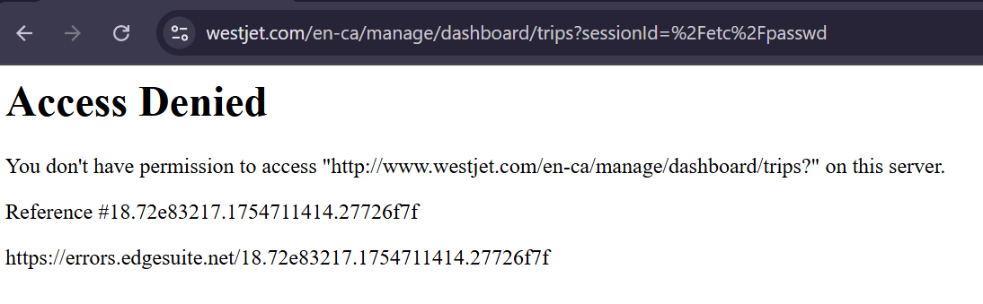

Again, it still leads to a 403 forbidden error.

Finally, we will attempt to test URL encoding using ‘..%c0%af..%c0%af’, as web applications may sometimes only perform one level of decoding, meaning we can potentially bypass the WAF.

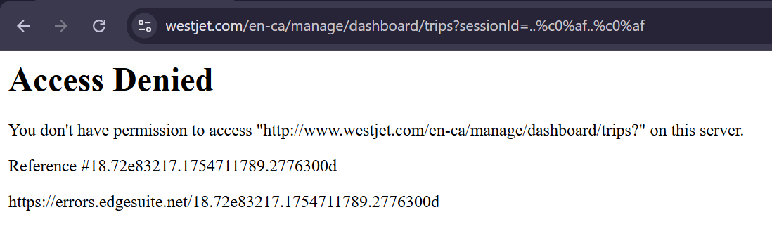

Unfortunately, it still gives a 403 forbidden error.

Even with encoded path traversal, absolute path and URL encoding, we are still given a 403 forbidden error by the WAF.

Moreover, we can see that there is no stripping performed on the path traversal sequences in the URLs, meaning ‘……//’ for example will not work as it directly denies any path traversal or absolute path attempts.

This shows that the WAF effectively decodes more than 2 levels of encoding and checks if the decoded value matches to any path traversal methods such as ‘…/…/’, giving a 403 forbidden error if so.

This ensures that attackers are unable to obtain credentials of users on the server to gain unauthorised access to it and perform post-exploitation activities.

#### Conclusion

Overall, WestJet has ensured proper implementations of security measures to prevent path traversal attacks such as path name sanitisation or directory whitelisting, which is allowing certain directories to be viewable by either employees, users or administrators for example, alongside the inclusion of a WAF to detect path traversal attempts.

Hence, this ensures sensitive files on the server that is hosting the web application cannot be leaked such as ‘/etc/passwd’, which contains the credentials of users on the web server, or internal documents that could expose WestJet’s financial or employee records, damaging their Confidentiality.

Thus, it ensures no unauthorised access to WestJet’s web server via the use of the dumped credentials from the ‘/etc/passwd/’ file, which would allow malicious actors to perform pivoting/tunnelling and as such post-exploitation activities such as lateral movement across WestJet’s network or stealing more internal and confidential documents, which would cause financial or employee data to be leaked via internal documents, leading to damages financially and employee loyalty.

Hence, WestJet can freely operate without any worry of such documents or credentials from being leaked.

Teams ought to stay alert when implementing file related features, and ensure that features influencing files paths should not be able to read or overwrite files it should not.

As the site is currently not vulnerable to path traversal, WestJet has shown that they comply with access control measures that ensure that unauthorised access to files and directories is not possible, also showing full compliance with data measures that are set in industry security standards and frameworks, like the OWASP Top 10. In the future, WestJet should maintain a high safety standard, ensuring that exploits like path traversal and others will continue not to function.

A recommendation is to ensure that the security team performing the periodic WAF rule reviews would include a section on understanding and testing new path traversal techniques. This walk-a-mile approach ensures that the security team understands how the path traversal technique works exactly and how to adjust the WAF rules based on that. This leads to the WAF being more secure and up to date.

1. Insecure Direct Object References (IDORs)

#### Exploiting the session id on ‘/manage/dashboard’ directory



As seen above, when accessing the ‘/manage/dashboard’ directory, a session ID is automatically given to the user.

The first 3 values ‘9-8-2025’ are the current day, month and year.

For the next 4 values, re-accessing the page as seen below shows the current time of where WestJet is located and the last value is unknown.

Hence, it will be assumed that the last value is the unique session identifier provided to the user which we can confirm by using Burp Suite, potentially allowing us to view another user’s trips.



We will be exploiting the unique session identifier in Burp Suite’s repeater.



We will change 81809 to 17191 and see the result by sending the request.

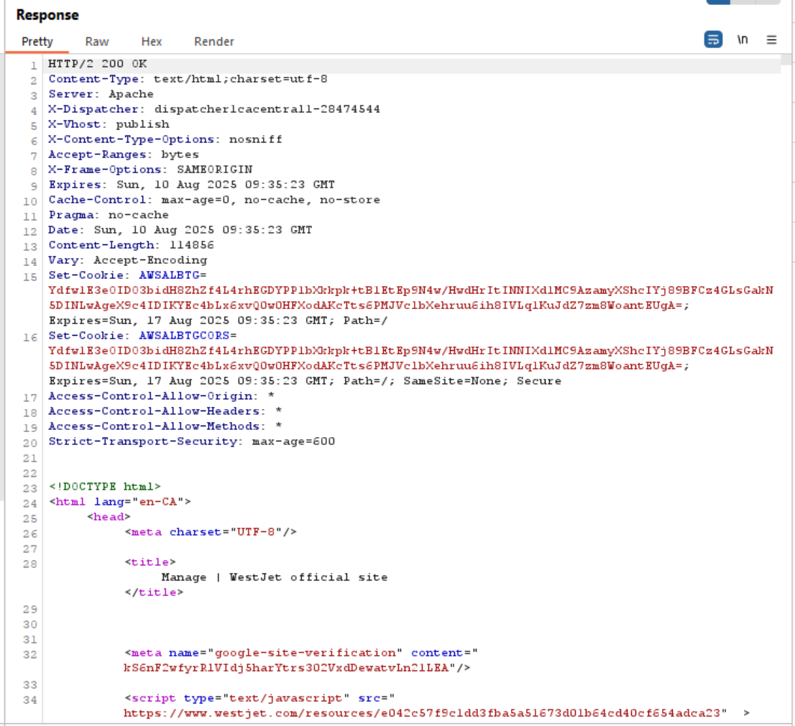

As seen above, we have obtained a 200 Success response, meaning the response was validated.

We will now open the response in Burp Suite’s Chromium proxy browser to confirm it.

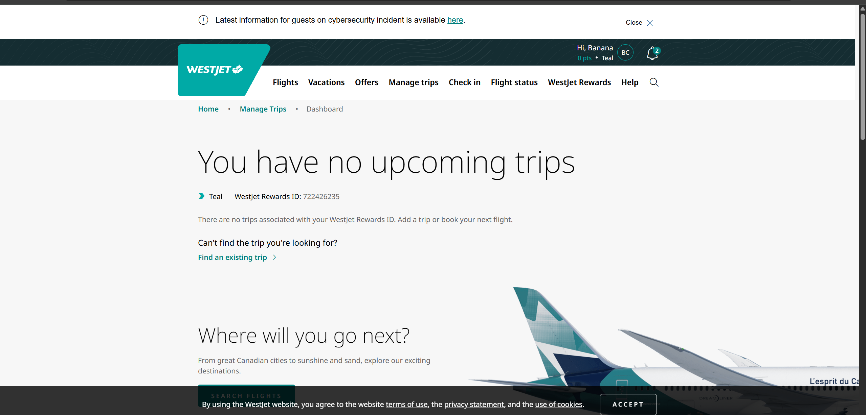

Unfortunately, upon opening the browser in Chromium, the user account did not change, and we cannot view any other user’s upcoming trips.

We will try again with another value.

We will try with ‘0’ this time, a unique value as certain businesses handle this value differently.

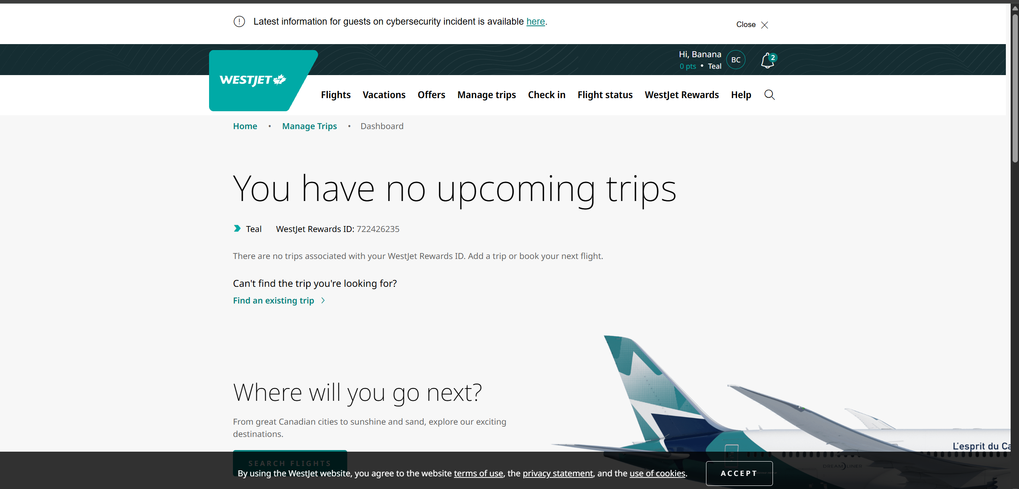

We still get the same response as before.

As such, we can probably assume that the last value is not a unique session identifier and thus not exploitable.

On the Manage Trips page, we can find a form where you can submit a card number, city, and dates to get inflight purchase information. If this was vulnerable to an IDOR attack, it would mean that we could find the purchases made by other customers, the last 4 digits of their credit card number, the city from which they departed, and a range of time during which the flight was made.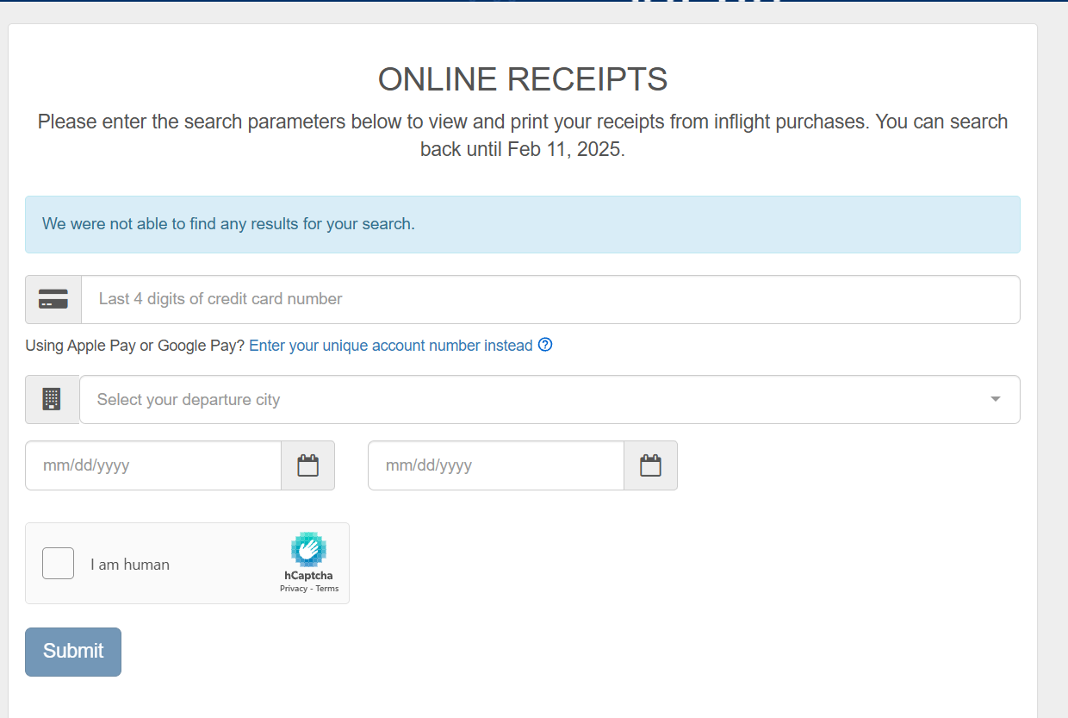Additionally, this form does not require you to log in for it to be accessible, meaning it is publicly accessible. In the image below, I have accessed the site in Firefox Private Browsing. This means that it cannot check that the card number actually belongs to the person who sent the request. 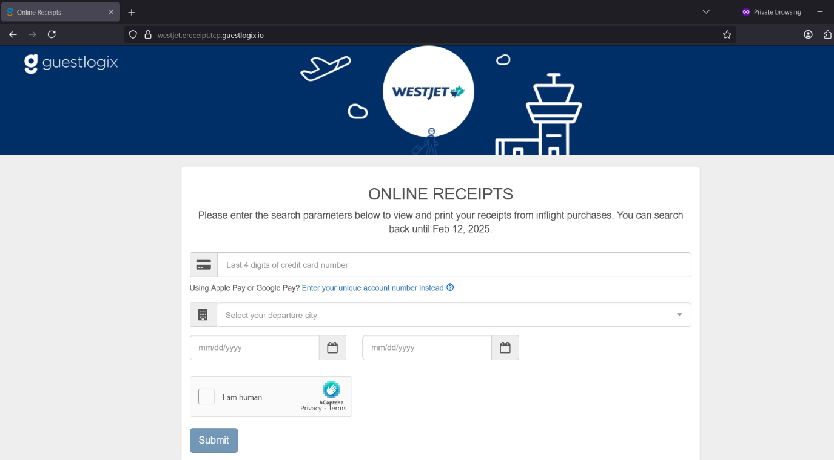

This would allow a brute-force attack to discover user information or confirm the last 4 digits of a user’s credit card number, representing a significant data security risk.

However, the page only allows you to view receipts from a range of 3 days at a time, greatly increasing the number of attacks required to find useful information.

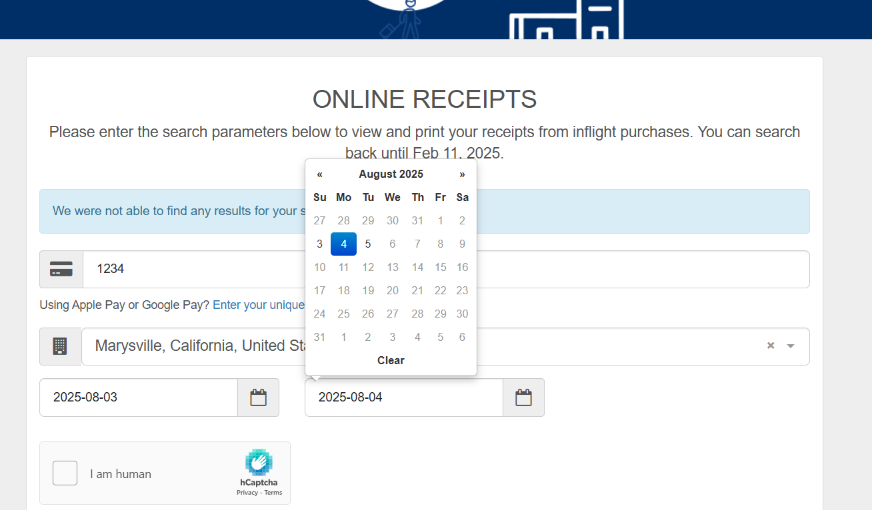

Additionally, this page uses a CAPTCHA system to prevent automated attacks.

The page does not show different error messages for if you did not complete and submit the CAPTCHA, compared to if you completed the CAPTCHA but no valid purchases were found.

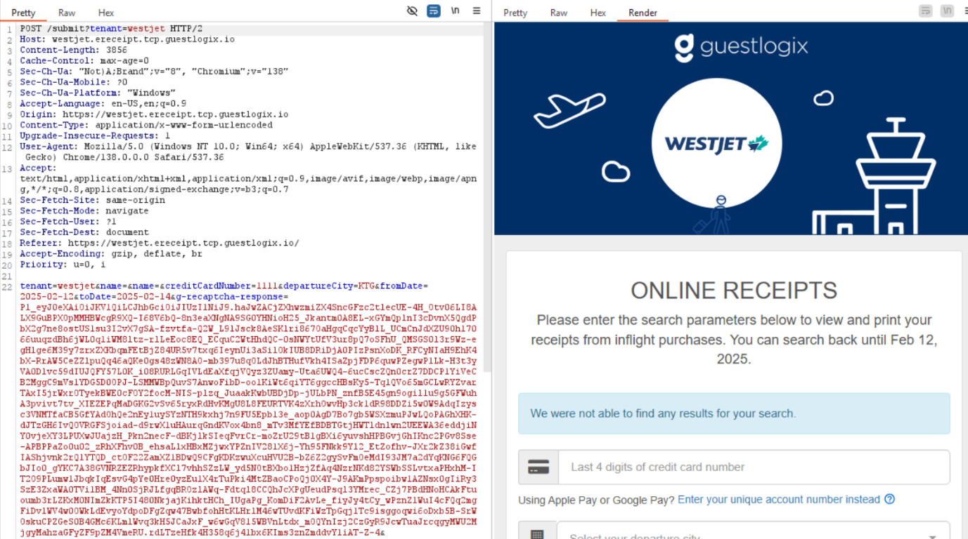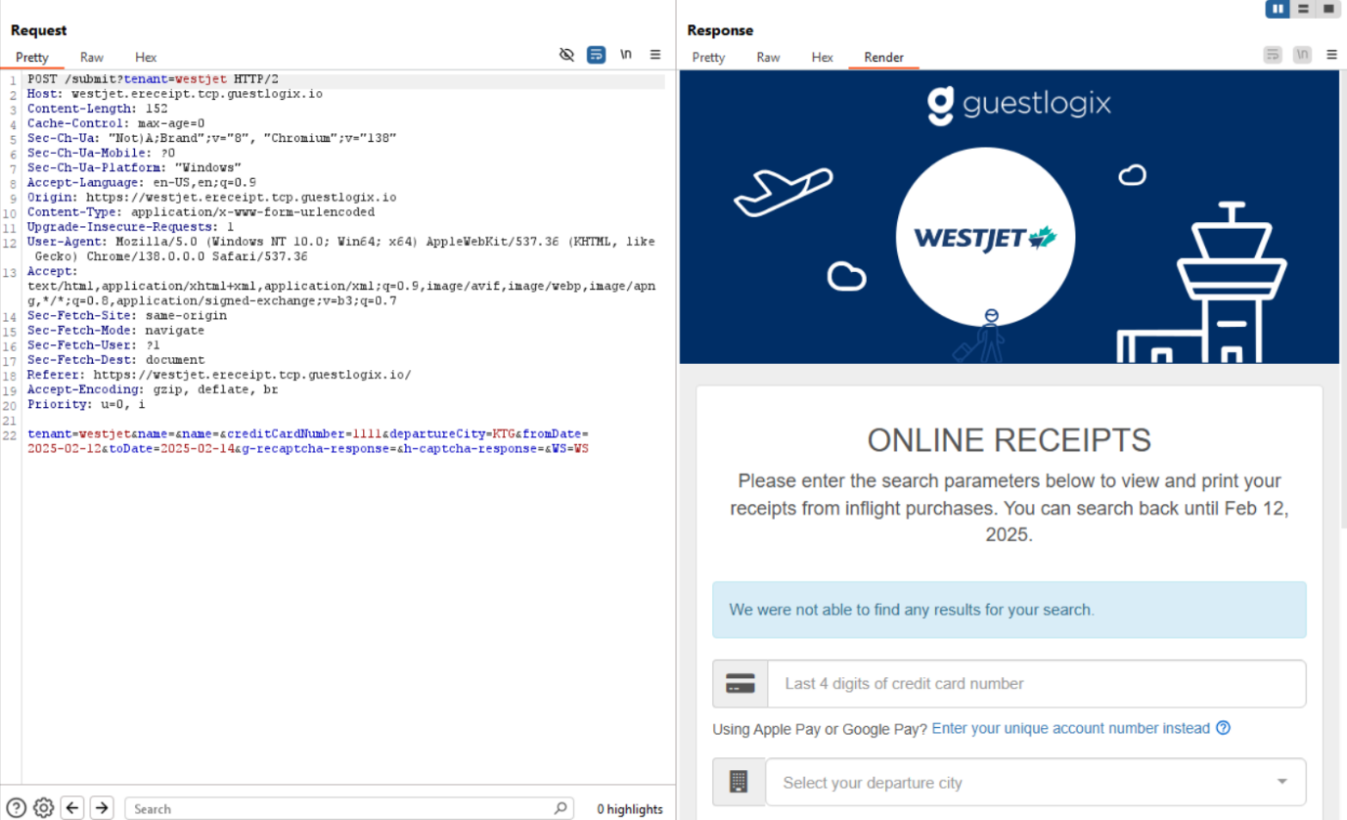Both pages show the same error message.

Checking using the Burpsuite proxy browser, there is no difference in the requests sent or received regardless of whether the CAPTCHA was completed.

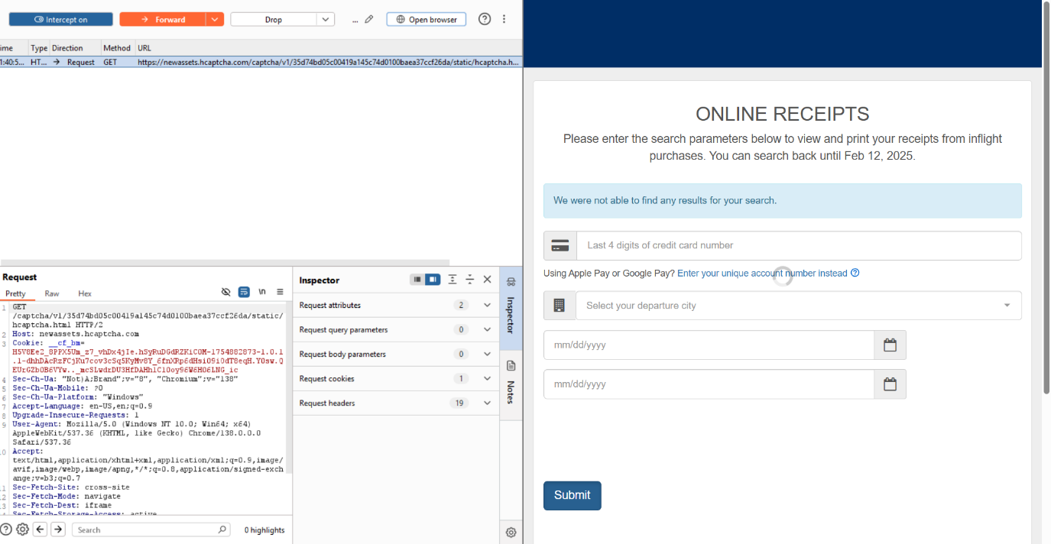

Additionally, when the form request is sent, disregarding a request that sends the CSS information for the error message, the page can display the error message even when intercept is activated, meaning that the error message is being handled client-side.

Based on this behavior, we can assume that the server only sends back a request with purchase information if all the submitted information is correct and refers to real purchases that have been made. Then, if no request is detected within a certain time, the page automatically displays the error message, meaning the error message does not provide any information on whether the provided information is valid. This also makes it impossible to determine if a replay attack that resends CAPTCHA information would function. This makes IDOR attacks to gather information on other customers’ purchases infeasible, as it is unclear if CAPTCHA information could be reused to perform brute-force attacks against the form.

#### Conclusion

Overall, WestJet has prevented and mitigated IDORs from a multitude of security measures such as the use of CAPTCHAs to prevent automated attacks from Burp Suite’s intruder, through server-side verifications or non-vulnerable URL parameters.

As such, malicious actors would not be able to access and view another user’s account, gaining unauthorised access to their personal details, credit card details etc.

Hence, this ensures their data cannot be modified, hijacked or exfiltrated as a result, preventing losses in trust between consumers and WestJet, or privilege escalation if a malicious actor was able to gain access to an administrator’s account and hence can view the ‘/administrator’ directory, ensuring WestJet can operate smoothly without any issues or disruptions.

This high level of data security within WestJet generally shows compliance with industry standards regarding data handling, and the claims made in its privacy statements. However, the fact that the receipts page is accessible without logging into a user account is potentially a concern even though an IDOR attack is not feasible to execute there, as it may possibly conflict with the data handling standards established within the regions where WestJet operates, like the UK and the European Economic Area.

In this scenario, although an IDOR was found, there were measures in place to prevent an IDOR attack. Still, we recommend the use of indirect reference maps. Instead of exposing the actual number of the session id for example, we can reveal to them a random string of characters such as iOhjFuvbWeIoq. However, on the server side, the random id is mapped to the actual session number. This makes it hard to anticipate or guess the session id.

However, misconfigurations or new handling features could reintroduce this risk. During development of similar future deployments, a core focus should be on recognizing when a feature exposes identifiers or references that could be manipulated. Even if the data seems harmless, teams ought to stay vigilant of how it could potentially be combined with other information to cause harm, which will help in catch potential IDORs before they can be exploited.

# Appendix

## Wafw00f

Check for what kind of web-application firewall WestJet is using

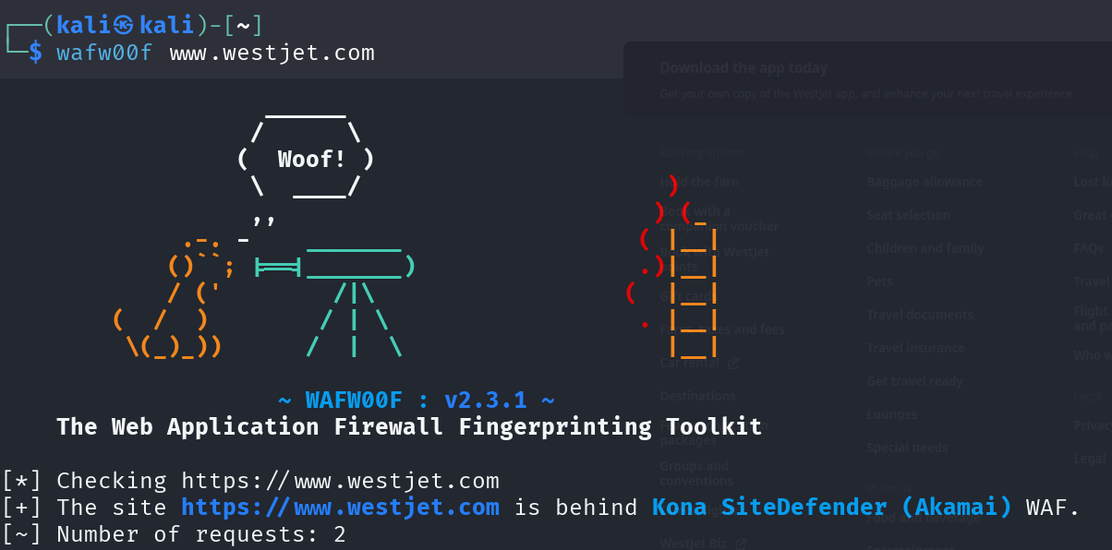

## Zaproxy

Passive spidering done on [www.westjet.com](http://www.westjet.com) before Kali Linux VM froze to find any potential vulnerabilities.

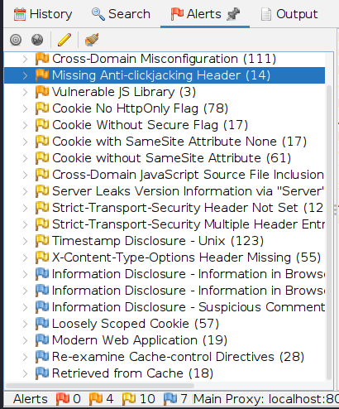

## Gobuster

Scan done on [www.westjet.com](http://www.westjet.com) to enumerate for potential directories/orphaned pages





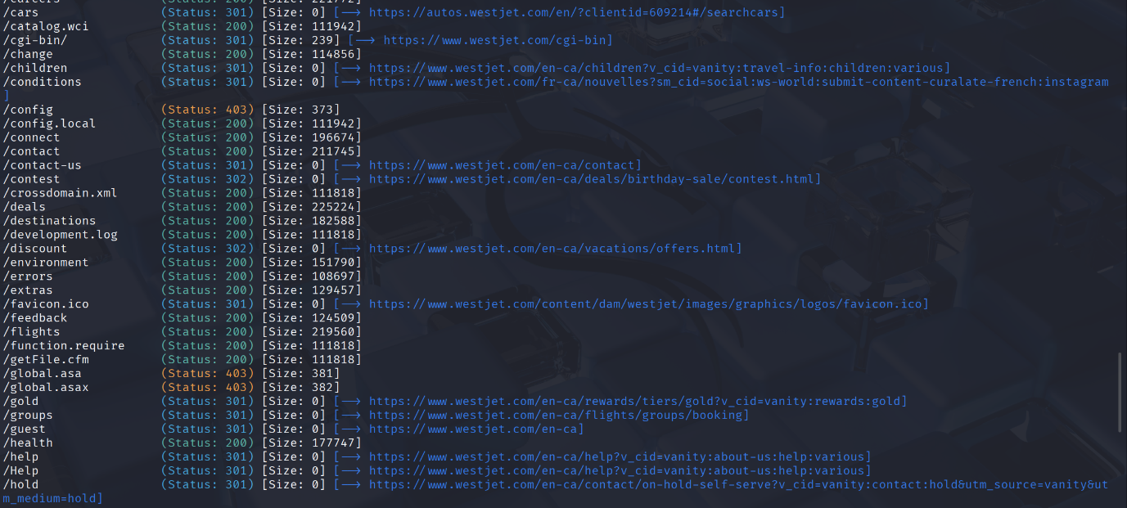

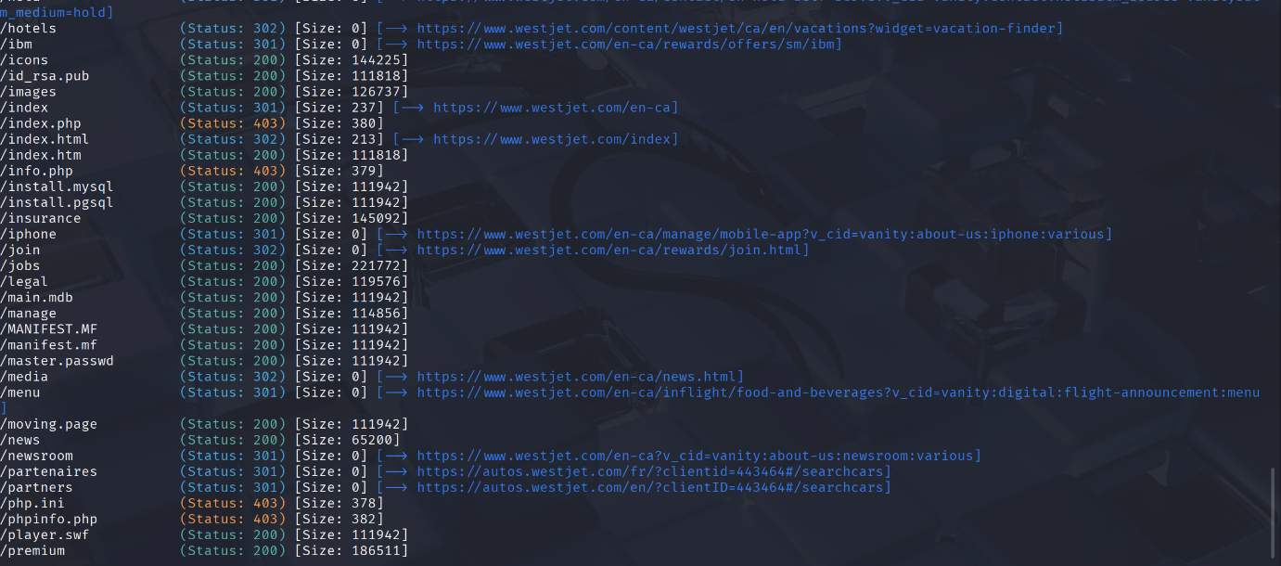

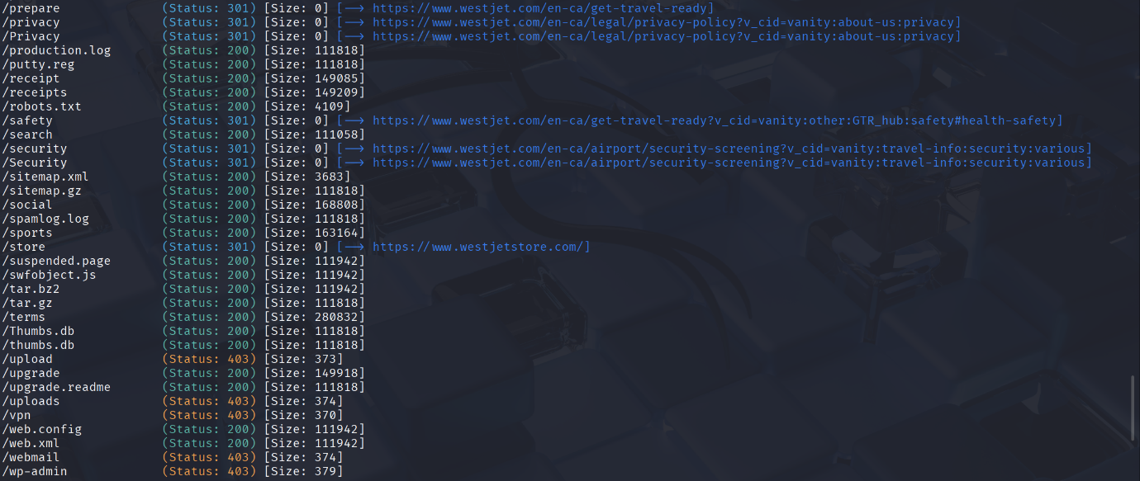

Scan done on [www.westjet.com/en-ca/manage](http://www.westjet.com/en-ca/manage) to enumerate for potential directories/orphaned pages

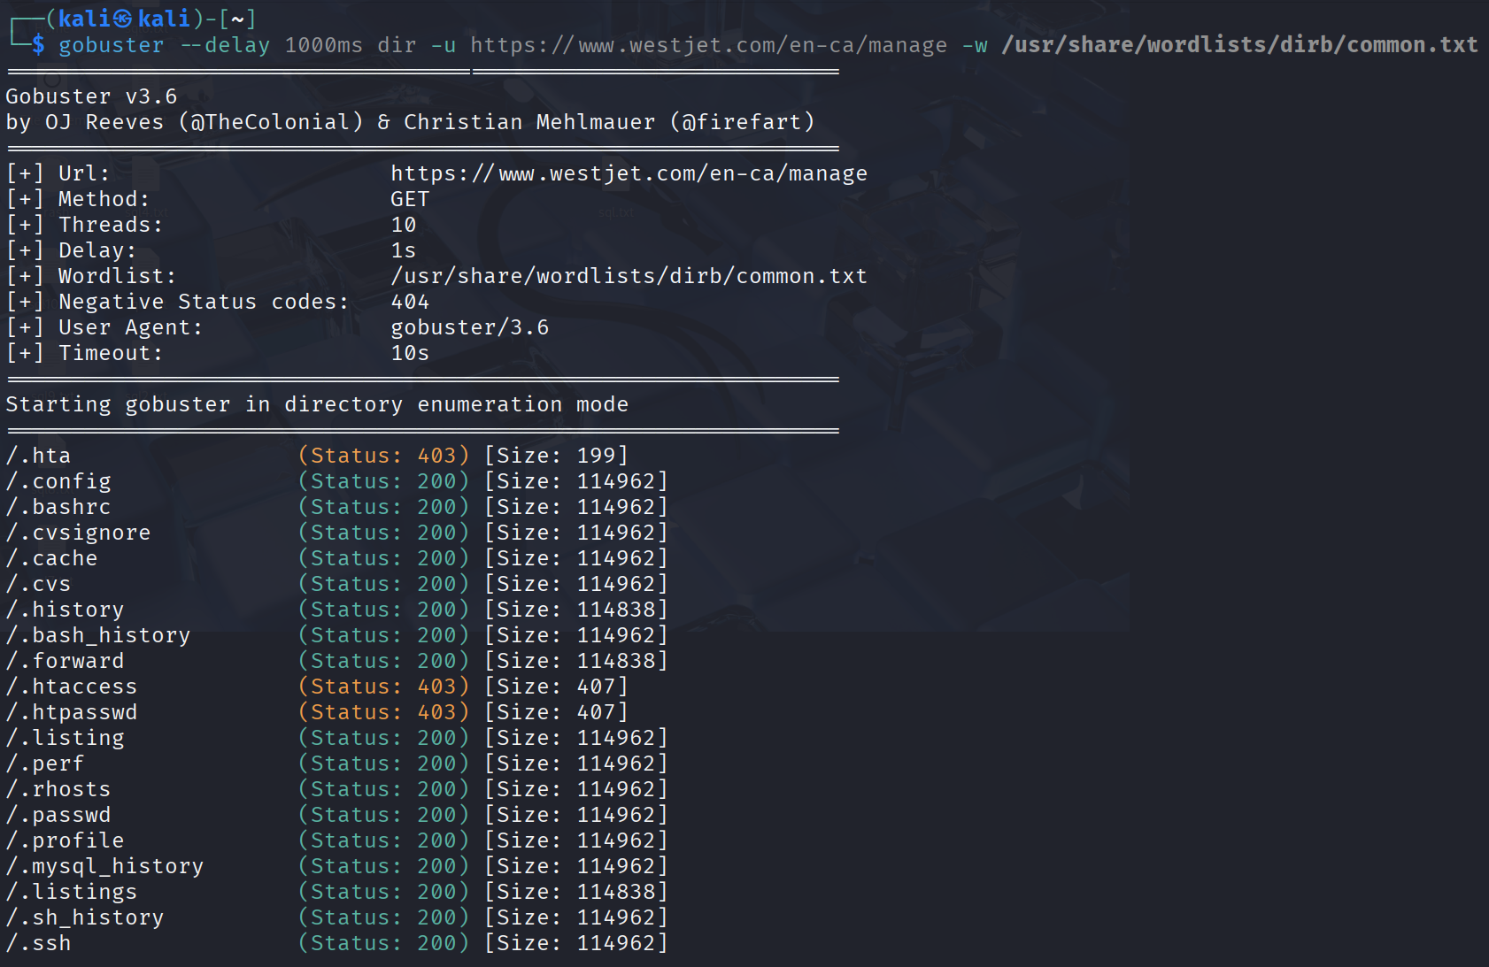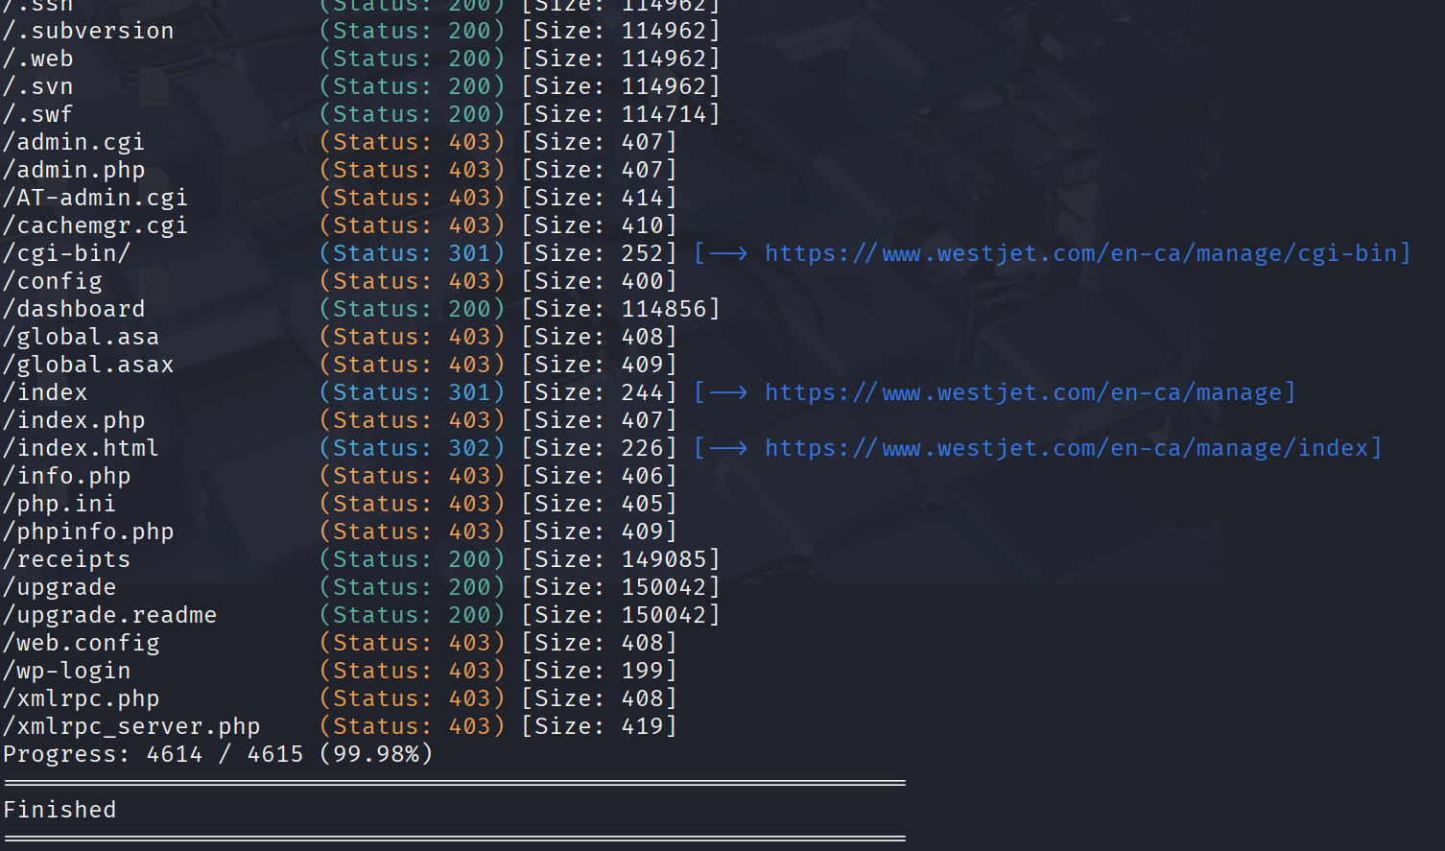

## XSS Payloads

Below is a list of the XSS payloads used, taken off <https://github.com/payloadbox/xss-payload-list>

<script>alert(1)</script>

"><script>alert(1)</script>

'><script>alert(1)</script>

<img src=x onerror=alert(1)>

<svg onload=alert(1)>

<input onfocus=alert(1) autofocus>

"><body onload=alert(1)>

"><img src=x onerror=alert(1)>

"><svg onload=alert(1)>

";alert(1);//

';alert(1);//

`alert(1)//

" onclick=alert(1) x="

{{<scr<script>ipt>alert(‘xss’);</scr</script>ipt>}}

<https://www.openbugbounty.org/reports/3135281/>

<https://www.openbugbounty.org/reports/1212551/>

<https://www.openbugbounty.org/reports/1014219/>

## Path Traversal

<https://owasp.org/www-community/attacks/Path_Traversal>

## Amass subdomain scan

Here is the full output of the subdomains found

Passive scan:

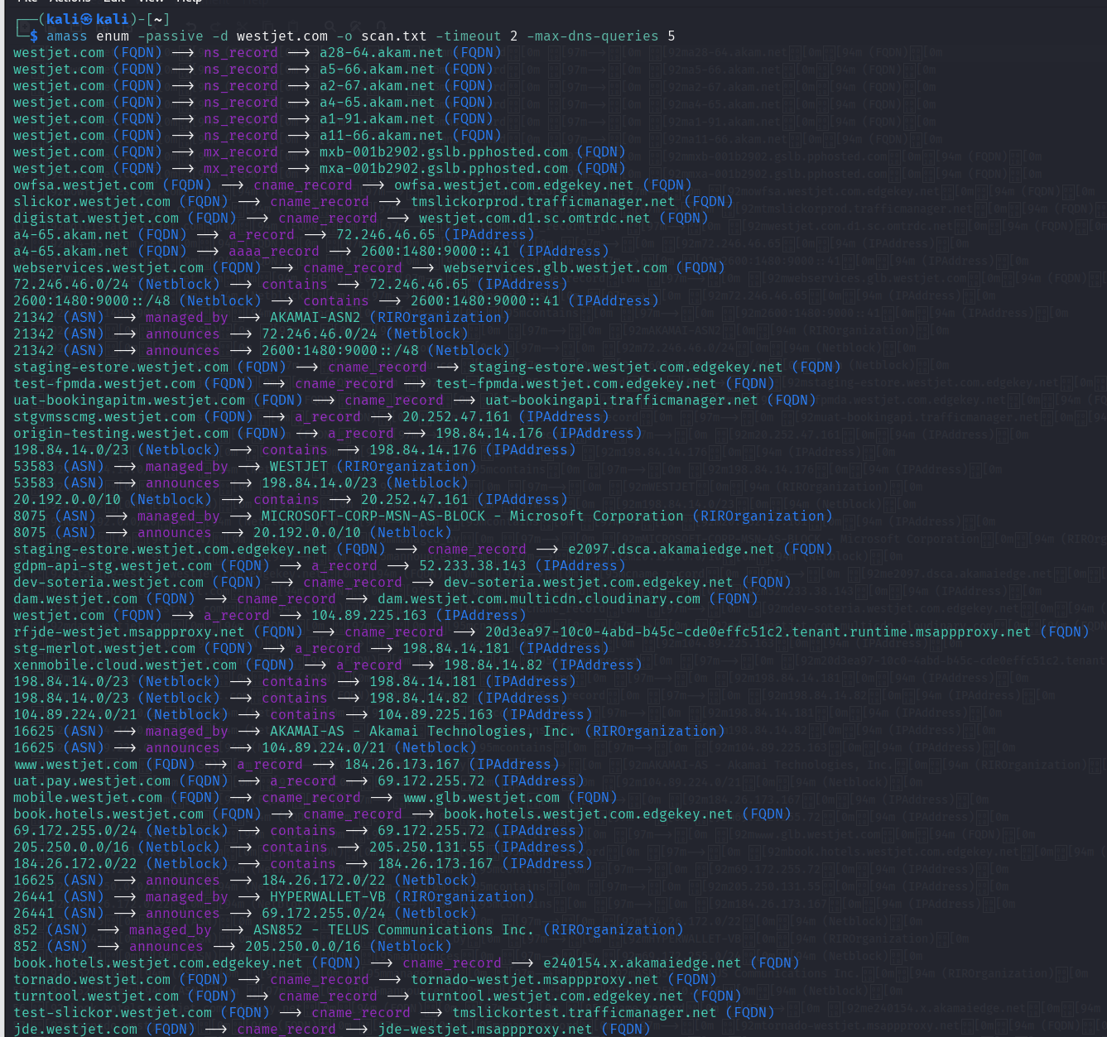

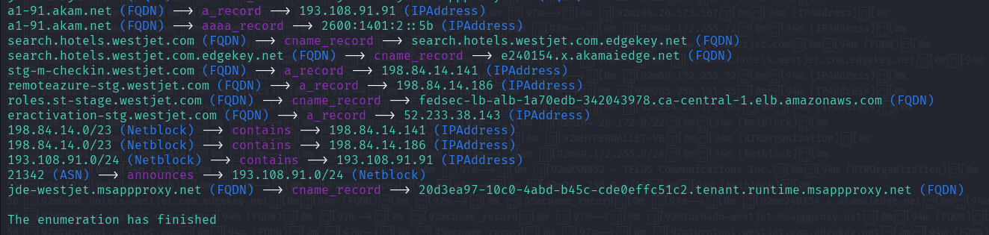

Output of the scan in a txt file

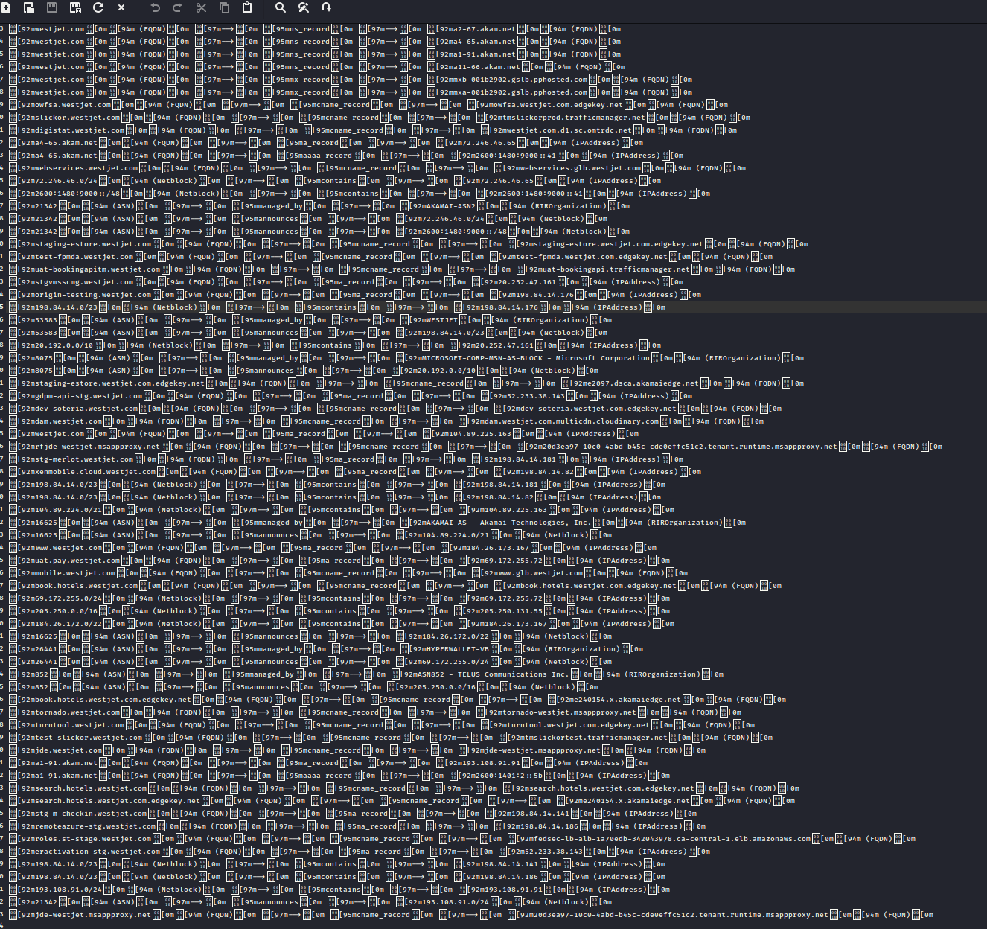

Active scan:

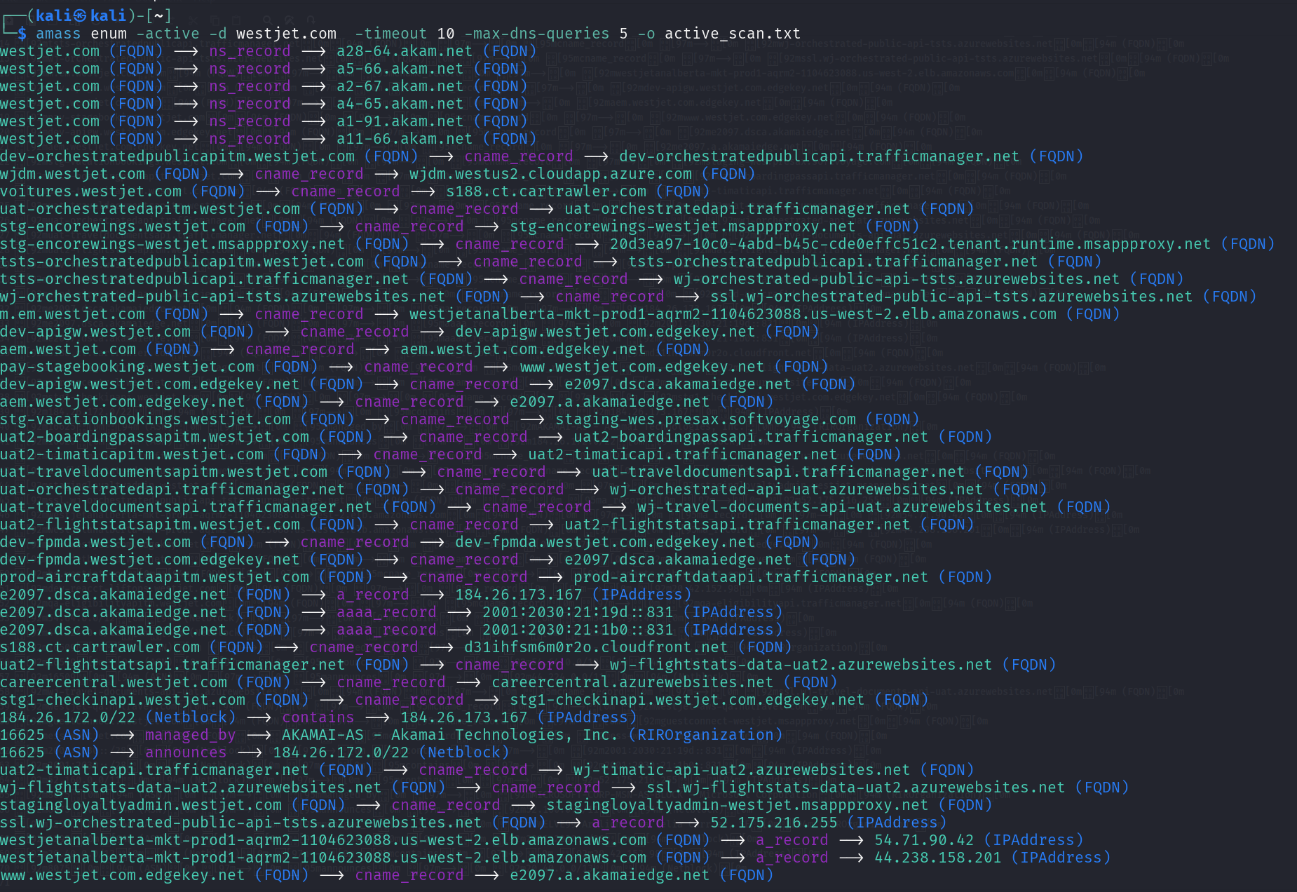

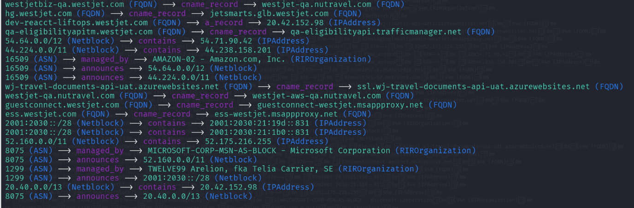

Output of the scan in a txt file

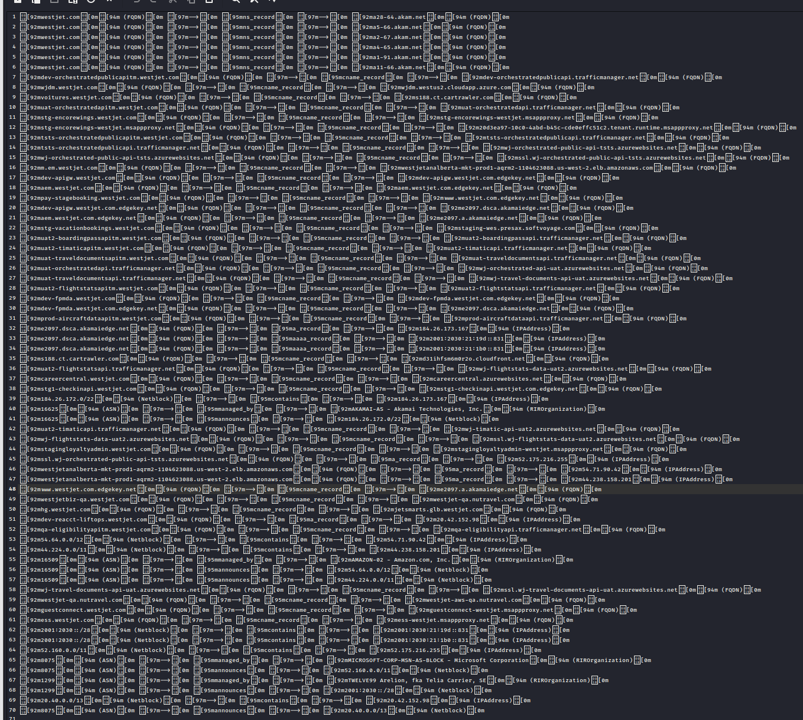

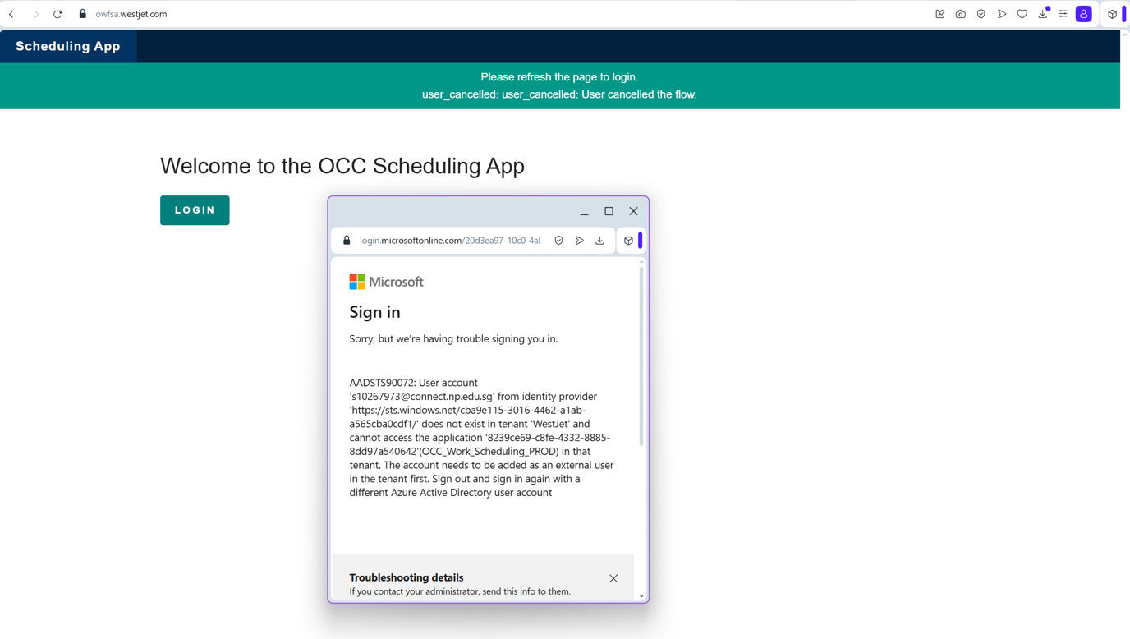

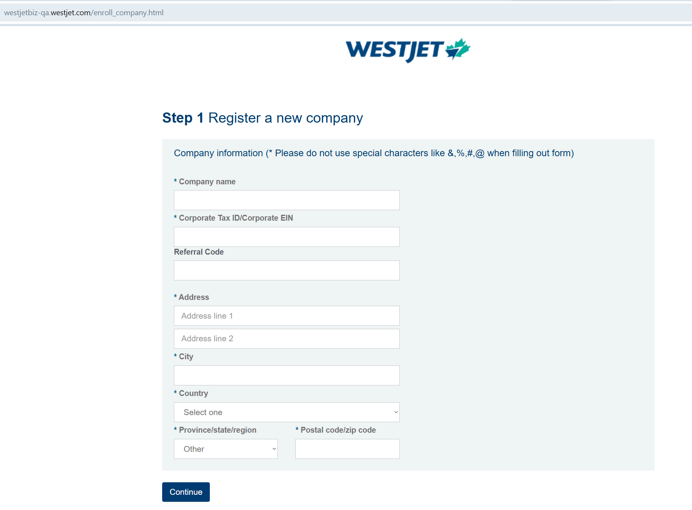

The image below is likely their main staff portal site

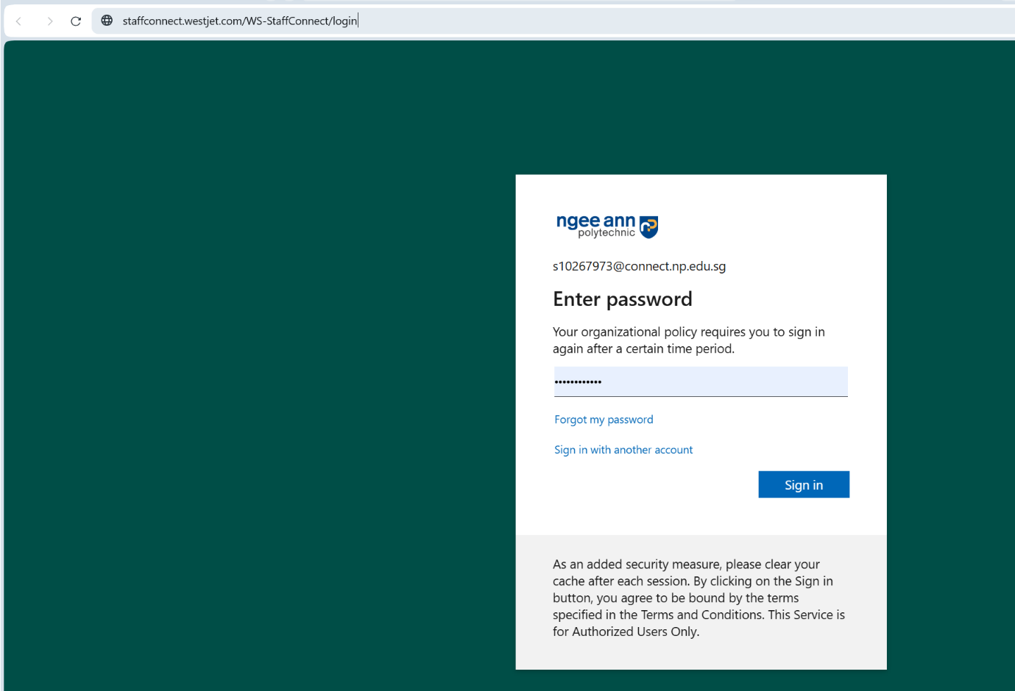

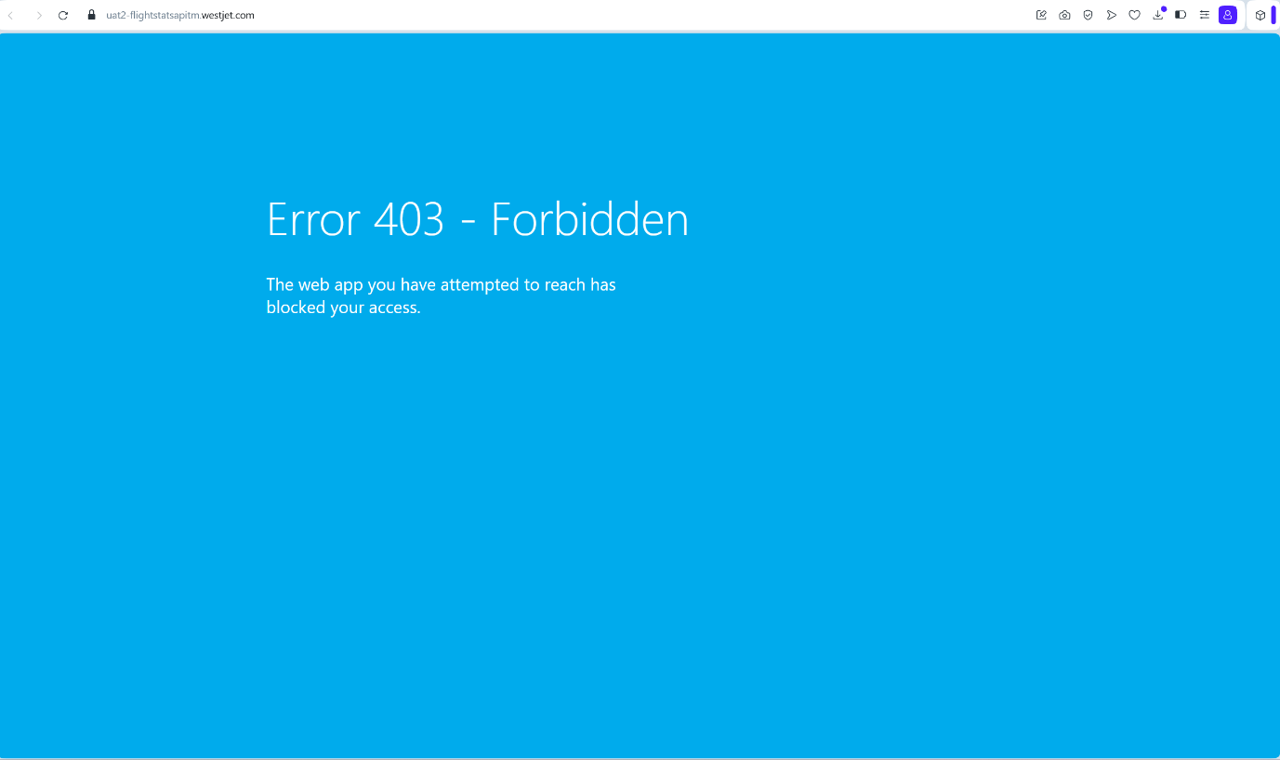

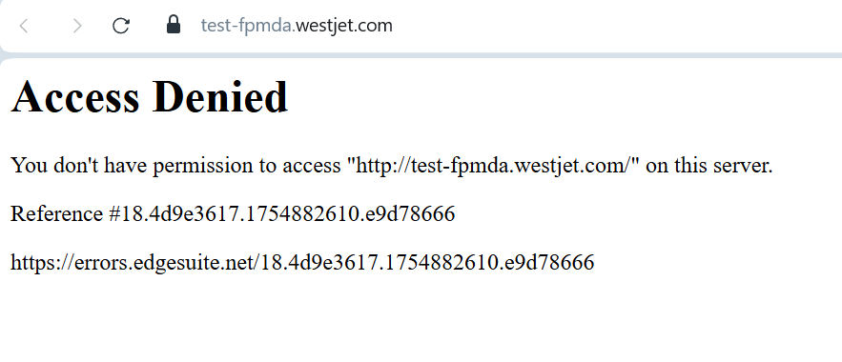

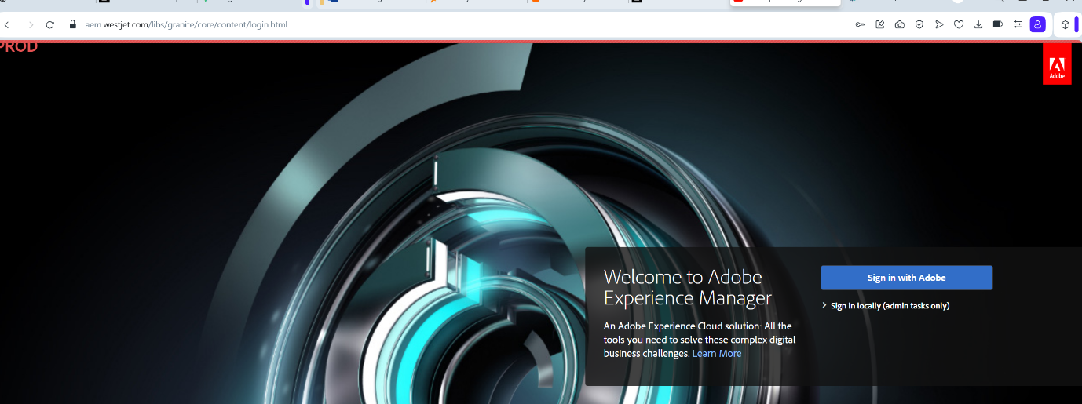

Here is the list of the sites that didn’t lead to a 404

<https://uat.pay.westjet.com/hw2web/landing.xhtml>

<https://digistat.westjet.com>

<https://uat2-flightstatsapitm.westjet.com>

<https://staging-estore.westjet.com>

<https://test-fpmda.westjet.com>

<https://uat.pay.westjet.com/hw2web/landing.xhtml?faces-redirect=true&refreshme=true&error=true&loginId=privacy@westjet.com>

<https://staffconnect.westjet.com/WS-StaffConnect/login>

<https://owfsa.westjet.com>

<https://aem.westjet.com/libs/granite/core/content/login.html?resource=%2F&$$login$$=%24%24login%24%24&j_reason=unknown&j_reason_code=unknown>